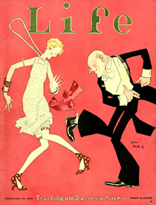
Names: Jazz Age Culture

Radio

Movies
Silent Film Era: Charlie Chaplin’s “The Kid”
The First Talkie “The Jazz Singer”
“Steamboat Willie”
Summary
Music
Dipper Mouth Blues, King Oliver’s Creole Jazz Band
Jubilee Stamp, Duke Ellington and his Orchestra
St. Louis Blues, Bessie Smith (Louis Armstrong on cornet)
The Charleston
Let’s Do It, Cole Porter
What are elements these songs have in common? What is different? Which songs seem to be related? (In other words, are they of a similar style or evolution?)
What kind of instruments are used in the songs?
What is the subject matter?
How do these songs represent 1920s Culture?
Literature
What do you think Gertrude Stein meant by a “Lost Generation”?
In what ways do “Lost Generation” writers depict the post-WWI era?
What themes or ideas are evident in each of these excerpts?
How are these pieces similar? How are they different?
In what ways do these excerpts relate to 1920s Culture and Society?

Advertising

Coca-Cola
Ford
Red Rock Cola
Lucky Strike “Reach for a Lucky…”
Lucky Strike “20,679 Physicians Say…”
Maybelline

