American I Review Packet
Legislation

- Alien and Sedition Acts
- Judiciary Act of 1801
- American System
- Missouri Compromise
- Tariff of 1828
- Gag rule
- Wilmot Proviso
- Compromise of 1850
- Fugitive Slave Act
- Kansas-Nebraska Act
- Wade-Davis Bill
- Reconstruction Act of 1867
- Compromise of 1877
- Force Bill

- SC threatened to secede over this “abomination”, claiming the federal law government helped the North and hurt the South; subject of the famous Hayne-Webster debates
- This bill proposed banning slavery in all of the territory gained from Mexico in the war; it was never passed
- This act was passed to prevent Southern states from making laws that violated the newly-passed 13-15th Amendments
- These acts were passed to keep the Democratic-Republican party from gaining popularity (and the Federalist party from losing power)
- This bill was passed by Congress at the beginning of the Reconstruction period; Lincoln used the pocket veto to kill it
- This compromise was made to settle a tie for president and give Southern states “home rule” and “redemption” to Democrats
- This compromise was created after the war with Mexico to deal with the issue of California being admitted as a Free state (because it crossed the 36’30° line)
- This act was passed to create new federal court positions for Adams to fill with Federalists before he left office – overturned in Marbury v. Madison
- This bill proposed banning slavery in all of the territory gained from Mexico in the war; it was never passed
- This act was passed by the Radical Republicans in Congress; it set up a military occupation of former Confederate states and created the Freedman’s Bureau
- This plan was Congress’s attempt to unify the economic regions of the country by creating canals, roads, tariffs, and a national bank
- This compromise helped preserve the balance of Slave and Free states in Congress; overturned Dredd Scott v. Sanford
- This law was passed to temporarily keep the abolition debate out of Congress
- This was the part of the Compromise of 1850 passed to make the South happy; it resulted in some northern states passing personal liberty laws

Political Parties, Supreme Court Cases, and Amendments

- Federalist Party
- Democratic-Republican Party
- Democratic Party
- Republican Party
- Whig Party
- Free-Soil Party
- Know-Nothing Party
- Marbury v. Madison
- McCullough v. Maryland
- Worcester v. Georgia
- Dred Scott v. Sanford
- Plessy v. Ferguson
- 12th Amendment
- 13th Amendment
- 14th Amendment
- 15th Amendment

- Gave citizenship and civil rights protection to anyone born or naturalized in the U.S.
- Opposed to slavery in Western Territories, died out
- For strong state governments, led by Jefferson and Madison
- Ruled that segregation laws were constitutional
- Supporters of Jackson, “redeemed” in Southern states during Reconstruction
- Declared that voting rights could not be denied based on race or former slave status
- For strong national government, led by Hamilton and Adams
- “Umbrella” party for those opposed to slavery in Western Territories
- For Nativism, also called the American Party
- Made slavery and indentured servitude unconstitutional
- Established principal of judicial review
- Overturned the Missouri Compromise because it violated the 5th Amendment
- Opposed to Jackson, for the American System
- Ruled in favor of the Cherokee tribe, but Jackson said he would not enforce the decision
- Established the president and vice-president ran on the same ticket, fixed the issue of the Election of 1800
- Ruled the states could not nullify federal laws, protected the Bank of United States

President | Policy Names/Era/Quote | Description/Details
Washington/ Adams

Jefferson

Jackson

Polk

Lincoln

Johnson/ Grant

Presidential Policies
Description/Details
- Rebuild South and integrate freedmen, Fight for control with Congress, social backlash, government corruption, Civil War amendments, Greater black participation in government, Jim Crow society
- Uphold supremacy clause, establish presidential precedent, establish the courts, stay out of French Revolution and conflict between Britain and France, Challenges to 1st amend., States challenge federal supremacy, midnight judges lead to Marbury v Madison
- Fought secession in the Civil War to preserve Union, issued Emancipation Proclamation showing national commitment to end slavery, first military draft
- First peaceful transfer of power, Louisiana Purchase (constitutional?), Lewis and Clark Expedition, less formal presidency, Embargo Act to avoid war, roots of modern democrats
- Hands-on commander-in-chief during Mexican War, Expansionist, established current borders of 48 states after Mexican Cession and Gadsden Purchase
- First Democrat, universal male suffrage, appeal to common man, Forcefully dealt with Nullification Theory (until Clay’s compromise), frequent use of veto, economic policies lead to Panic 1837

Policy Names
- Preserve the Union
- New Nation, Neutrality
- Manifest Destiny
- Reconstruction
- Jeffersonian Era
- Jacksonian era

Manifest Destiny
Using your text and class notes, complete the chart below to show how the United States accomplished its expansion to the Pacific.

Territory | Date Acquired | Previous Owner | Circumstances of Acquisition
Original 13 States

States as of 1818

Louisiana Territory

Florida

Oregon Territory

Texas

Mexican Cession

Gadsden Purchase

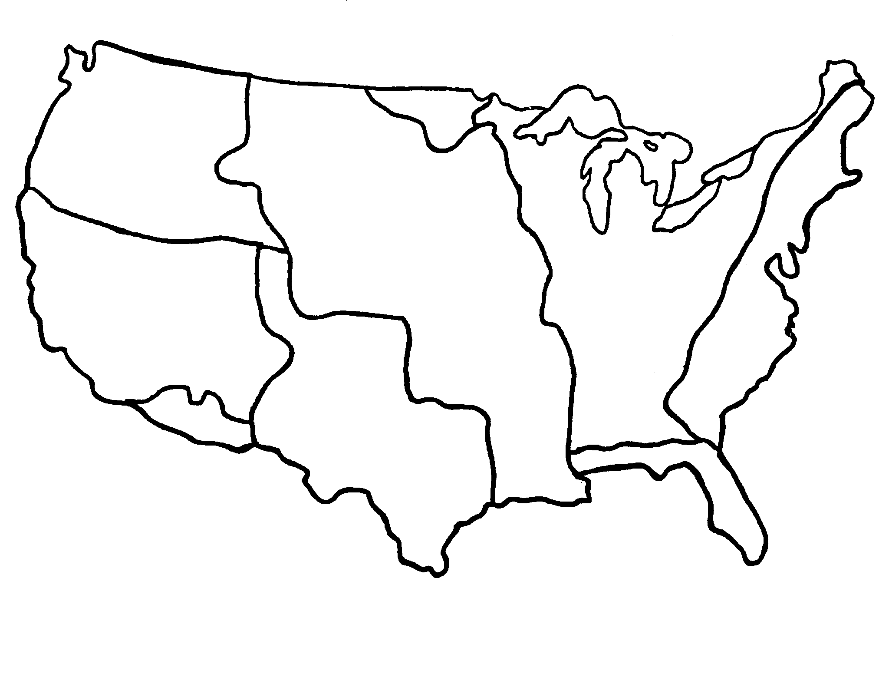
Growth of the United States

Key:
The original 13 states
US after the Treaty of Paris of 1783
Land gained by the Adams-Onís Treaty
The Louisiana Purchase
Land gained under the Convention of 1818
Texas Annexation
The Oregon Country
The Mexican Cession
The Gadsden Purchase

War Review
1. War  2. Sides | Dates | Causes | Leaders | Battles | Outcome
1.  2. | 1754-1763
1.  2. | 1776-1789
1.  2. | 1812-  1814
1.  2. | 1846-  1848
1.  2. | 1861-  1865
Answers to the War Review

Causes
- Impressments of US sailors, infringement on American trade on the seas, competition for control of the Great Lakes
- Taxation without representation
- Manifest Destiny, Conflict over the TX border, expansion fever
- State’s rights conflict, Dred Scott decision, economic regional differences, election of Lincoln, showdown at Ft. Sumter
- Control of the Ohio River Valley, control of the fur trade, war in Europe

War / Sides
- Civil War, Union (N) v. Confederacy (S)
- Mexican American War, Mexico v. United States
- War of 1812, Britain v. United States
- French and Indian War, France & Native Americans v. England
- American Revolution, British Soldiers v. American Colonists

Battles
- Monterrey, Santa Fe, Buena Vista, Mexico City, Bear Flag Revolt
- Great Lakes naval battles, burning of Washington D.C., New Orleans
- Fort Necessity
- Fort Sumter, Bull Run, Shiloh, Antietam, Gettysburg, March to the Sea, Vicksburg
- Lexington and Concord, Bunker Hill, Trenton, Saratoga, Guilford Courthouse, Yorktown

Notable Leaders
- Pres. Lincoln, U.S. Grant, Robert E. Lee, Sherman, Stonewall Jackson, McClellan
- George Washington
- Pres. Pol, Stephen Kearny, Zachary Taylor, Winfield Scott, John Fremont
- Pres. Madison, Andrew Jackson
- George Washington, King George III, Lord Cornwallis

Outcome
- Treaty of Guadaloupe Hidalgo: US gains Mexican Cession, later Gadsden Purchase
- Treaty of Paris, 1789: British recognize the United States of America
- Union reunited, federal government strengthened, 13, 14, 15th amendments passed, Reconstruction followed
- Treaty of Ghent: doesn’t solve the problems, later treaties: Rush Bagot Treaty, Convention of 1818
- Treaty of Paris, 1763: French lose control of Canada and North American land east of the Mississippi

Exploration and Colonization

- Mayflower Compact
- House of Burgesses
- Puritans
- Plantation economy
- English
- French
- Land ownership
- Religious freedom
- Indentured Servants
- Covenant
- Community
- Dutch
- Middle passage
- Cavaliers
- Virginia Company
- Direct Democracy

New England Colonies
- Settled by _____________ seeking religious freedom
- ___________________ – first written form of government
- ________________________– based on religious beliefs (i.e. – a theocracy)
- Often intolerant of other beliefs
- Practiced a form of ___________________ in town meetings
Middle Colonies
- Settled by English, __________, and Germans
- Colonists sought _____________________ and economic opportunity
Virginia and the Southern Colonies
- Immigrants sought land and economic opportunity
- Virginia ______________ – English nobility who received large land grants
- Poor English immigrants came as small farmers and artisans
- ________________ – agreed to work on tobacco plantations in exchange for passage to the New World
Jamestown
- Established in 1607 by the ______________________
- First permanent ___________________ settlement
- Virginia _____________________ – First elected assembly in the New World
Native Americans & Slavery
- Cause of Conflict – differing views on ______________________
- Diseases imported from Europe caused massive depopulation (smallpox)
- ______________ exploration in Canada – limited immigration from France resulted in better relations with native peoples.
- First Africans brought to Jamestown in 1619 to work on plantations
- _____________________ – based on large landholdings and the use of slave labor in
- the Southern colonies and Caribbean _________________ brought many Africans on brutal trip across Atlantic Ocean

The Early Colonies

- Rhode Island
- Quakers
- Seaports
- Plantation owners
- Dissenters
- Jonathan Edwards
- Slave labor
- Baptists
- Church of England
- Catholics
- Shipbuilding
- Puritan
- Pennsylvania
- Cash crops

New England’s Economy
- Economy based on __________________, fishing, lumbering
- _____________ beliefs – value of hard work and thrift – led to prosperous colonies
The Economy of the Middle Colonies
- Made up of New York, New Jersey, ________________, Maryland, & Delaware
- Growth of cities as ______________ and commercial centers (New York, Philadelphia)
Virginia and the Southern Colonies’ Economy
- Economy based on large plantations and ____________ in eastern coastal lowlands
- ____________– tobacco, rice, and indigo
Social Characteristics of the Colonies
- New England ________________– people who challenged Puritan beliefs
- Puritans grew increasingly intolerant of dissenters
- _______________– founded by Roger Williams & dissenters fleeing Puritan persecution
Middle Colonies
- ____________– Founder of Pennsylvania
- ____________– Founder of Maryland
Virginia and the Southern Colonies
- ________________________– dominated government and society
- ________________________– dominant religious institution
The Great Awakening
- Religious revival movement led by ________________
- Cnsequences – growth of evangelical religions (Methodists, _________________)
The American Revolution

- Independence
- Enlightenment
- Proclamation of 1763
- Self-evident
- Stamp Act
- Common Sense
- Grievances
- French and Indian War
- Boston Tea Party
- Thomas Jefferson
- Natural rights
- Boston massacre
- Popular sovereignty
- Social contract
- Declaration of Independence
- Lexington and Concord
- Taxes
John Locke
- ________________ philosopher from England
- ________________ - life, liberty, and property cannot be taken away
- ________________ – all power comes from the people (“consent of the governed”)
- ________________ – people form a government to protect their rights and people agree♣ to obey the rules established by their government
Thomas Paine
- Author of ________________ - pamphlet that challenged the rule of England
- He helped to change public opinion in favor of ________________
Anglo-French Rivalry
- ________________ fought between 1756 – 1763 drives French out of Canada & west British Actions after 1763
Measures to increase revenue and reduce cost of colonial defense
- ________________ – prohibited American settlement west of Appalachian Mountains
- ________________ – new direct tax on printed, legal documents
- New ______________ on tea and sugar
The Beginning of the American Revolution
- ________________ - British soldiers fire on American protesters in 1770
- ________________ - dressed as Indians, Americans toss tea into harbor to protest tax
- ________________ - First shots fired of Revolution were here in Massachusetts
- ________________ - signed by Second Continental Congress on July 4, 1776
The Declaration of Independence
- Written by ____________________
- “We hold these truths to be ________________, that all men are created equal, that they are endowed by their Creator with certain unalienable rights, that among these are life, liberty, and the pursuit of happiness.”
- Essentially a list of ________________ –complaints regarding the king’s rule

American Revolution & New Republic

- Benjamin Franklin
- Patriots
- Virginia Plan
- Great Compromise
- New Jersey Plan
- Battle of Yorktown
- Articles of Confederation
- Loyalists
- Neutral
- Federalist Papers
- Shay’s Rebellion
- Executive branch
- Patrick Henry
- James Madison
- Checks & balances
- George Washington
- George Washington
- Bill of Rights
- 3/5 Compromise
- Federalists
- Anti-federalists
- Independence
Differences among the Colonists
- _______________ believed in complete independence from England
- Led by ________________ of Virginia --“Give me liberty, or give me death!”
- Others known as ________________ remained loyal to Britain
- Most colonists remained ________________ and tried to avoid conflict
Factors Leading to Colonial Victory
- ________________ negotiated a Treaty of Alliance with France
- The leadership of ________________ and his Continental Army
- French Alliance in final victory at the ________________ in Virginia
Treaty of Paris, 1783
- Britain recognized American
- Northern border – along the Canadian border and Great Lakes
- Western boundary – Mississippi River
- Southern boundary – Florida border
Creating a Government
- The ________________ created a weak national government
- Provided for no common currency, power to tax, or ________________
- ________________ in Massachusetts shows the government’s weaknesses
The Constitutional Convention
- Large states favored the _______________, small states liked the _______________
- The ________________ made Senate equal; House represented by population
- Created _______________ with three equal branches: legislative, executive, judicial
- Placated Southern states with ________________ counting 3/5’s of slaves for representation in the House of Representatives
- ________________ – Chairman of the Convention
- ________________ – Father of the Constitution, led debates, authored Virginia Plan
Arguments for and Against Ratification
- ________________ favored it and wanted stronger central government
- Argued for ratification in ________________ by Hamilton, Madison, and Jay
- ________________ were against ratification, disliked strong government
- They wanted a ________________ to protect individual liberties
Early America & Expansion

- Virginia Declaration of Rights
- Cotton Gin
- Mexican
- Thomas Jefferson
- Railroads
- Reservations
- Cherokee
- Trail of Tears
- Eli Whitney
- Panic of 1837
- Treaty of Guadalupe Hidalgo
- Alamo
- California
- VA Statute of Religious Freedom
- Manifest Destiny
- George Mason
- property
- Spoils System
- Bank of the U.S.
- “Pet”

Virginia’s Influence on the Bill of Rights
- The _____________________ said rights that cannot be violated by governments
- Written by ________________, it became basis for the U.S. Bill of Rights
- The ________________, established principle of religious liberty
- Written by __________________ and guaranteed freedom of speech and religion
Early America, Westward Movement, and Economic Development
- ________________ was the belief the US should stretch from ocean to ocean
- The growth of ________________ encouraged the westward movement
- ________________ invented the ________________ which led to the spread of the slavery-based cotton economy in the Deep South.
Conflicts
- American migration into Texas led to an armed revolt against ______________ rule
- A turning point was the famous battle at the ________________, which Mexico won
- America’s later victory in the Mexican-American War led to the signing of the___________________________
- US acquired present-day states of ________________, Nevada Utah, Arizona
Impact on the Native Americans
- The ________________ were forced to march the ________________ from Georgia to Oklahoma resulting in thousands of deaths.
- Most tribes were confined to ________________.
Andrew Jackson’s Presidency
- Jackson used the ____________________ to reward supporters with government jobs.
- He supported eliminating ________________ qualifications to allow more people to vote
- Jackson distrusted the ________________ as an undemocratic tool of the Eastern elite.
- He withdrew government money from the Bank and deposited it in __________ banks
- His actions led to a serious economic depression and the ______________________.

Slavery, Abolition, & Women’s Rights

- Kansas-Nebraska Act
- High tariffs
- Harriet Beecher Stowe
- Compromise of 1850
- Dred Scott
- Stephen Douglas
- Bleeding Kansas
- Susan B. Anthony
- Abraham Lincoln
- Missouri Compromise
- Nat Turner
- Manufacturing
- William Lloyd Garrison
- Agricultural
- Elizabeth Cady Stanton
- Seneca Falls Declaration
- Vote

Economic Divisions
- The Northern states developed an industrial economy based on ________________.
- The Southern states developed an ________________ economy based on slavery
- The South opposed ________________ that made manufactured goods more expensive.
The Growing Division over Slavery and States Rights
- ______________________ published the abolitionist newspaper The Liberator.
- _______________________ wrote Uncle Tom’s Cabin showing evils of slavery
- A slave revolt in Virginia led by ________________ increased fear of further uprisings
The Sectional Crisis
- The ________________ admitted Maine as a free state and Missouri as a slave state and (b) drew an east-west line through the Louisiana Purchase with slavery prohibited above the line and allowed below the line, except that slavery was allowed in which was Missouri north of the line.
- The ________________ admitted California as a free state
- The ________________ repealed the Missouri Compromise and allowed the people of Kansas and Nebraska to decide whether to allow slavery ________________ - fighting in Kansas as pro- and anti-slavery forces battled
- Abraham Lincoln debated _________________ over slavery in the Illinois Senate campaign
- ________________ Case - a decision by the Supreme Court declaring that slaves were property and could be legally taken into any free state ________________ warned: “A house divided against itself cannot stand.”
The Women’s Suffrage Movement
- Women fought for suffrage, or the right to ________________
- ________________ – adopted by convention in 1848 called for equal rights for women.
- ____________________ and ________________ – both advocated women’s suffrage

The Civil War

- Secession
- Ft. Sumter
- Compromise of 1877
- Emancipation Proclamation
- Gettysburg
- Ulysses S. Grant
- Frederick Douglass
- Gettysburg Address
- Punish
- Jim Crow
- Robert E. Lee
- Andrew Johnson
- Antietam
- Radical Republicans
- Appomattox
- Reconstruction
- Southern
- 13th Amendment
- 14th Amendment
- 15th Amendment
- Election

Major events
- Lincoln’s election in 1860 led to the ________________ of 7 southern states
- Civil War begins when Confederates attack Union forces at ________________
- Battle of ________________ in Maryland marked deadliest day in US History
- Lincoln issued the ________________ after the battle, banning slavery in rebel states♣ ________________ - Union victory and turning point of the war
- In the ________________, Lincoln argued America was a nation ruled “of the people, by the people, and for the people.” ________________________ - site of Lee’s surrender to Grant
Key leaders and their roles
- ________________ – Union general, won victories after many Union generals failed
- ________________ – Confederate general of the Army of Northern Virginia
- ________________ – Former slave became an abolitionist and urged Lincoln to recruit former slaves and free blacks to fight in the Union army
Impact of Civil War and Reconstruction
- The period after the civil war when the south was rebuilding was ________________
- Lincoln believed the government should not ________________ the South but act with “malice towards none, with charity for all, in order to “bind up the nation’s wounds”
- _______________ favored guaranteeing voting rights and rights for African Americans
- Lincoln’s successor, ________________ was impeached
The three Civil war Amendments were added to the Constitution:
- ________________ – abolished slavery
- ________________ – guaranteed equal rights under the law to all Americans
- ________________ – guaranteed voting rights regardless of race, or slavery Reconstruction ended following the controversial ________________ of 1876
- Rutherford B. Hayes was elected through the ________________
- The ________________ Era began in which blacks in the South were denied rights
- ________________ States were left embittered and devastated by the war

Terms to know

Jamestown’s Failure
Great Awakening
Salem Witch trials
Colonists interactions with Natives
Decline of American Indian population
Mercantilism
Bacon’s Rebellion
Shay’s Rebellion
Salutary Neglect
Causes of American Revolution
Stamp Act
Intolerable Acts
Declaration of Independence
Battle of Saratoga
Treat of Paris 1783
Articles of Confederation Pros and Cons
Anti Federalists VS. Federalists
Jefferson VS. Hamilton economic policy
Three Fifths Compromise
Checks and Balances
Marbury v. Madison
Judicial Review
Louisiana Purchase
Lewis and Clark
War of 1812 Causes and Results
Industrial Revolution Results / long term effects
Jacksonian Democracy
Abolitionists
Temperance
Prison / Mental Health Reform
Spoils System
Cotton Gin
Monroe Doctrine
Missouri Compromise
Indian Removal Act
Manifest Destiny
Oregon trail, Santé Fe Trail, Mormon trail
Mexican War
Foreign Policy of Jefferson, Madison, and Monroe
Suffragists
North VS. South (political, economic, and cultural differences)
Popular sovereignty
Bleeding Kansas
Dred Scott Decision
John Brown
Nat Turner
Compromise 1850
Uncle Tom’s Cabin
Causes of Civil War
Election of 1860
Abraham Lincoln’s political platform
Jefferson Davis
Fort Sumter
First Battle of Bull Run
Battle of Gettysburg
Black Codes
Voting Restriction in the South
Impeachment of Andrew Johnson
13th, 14th, and 15th Amendments

