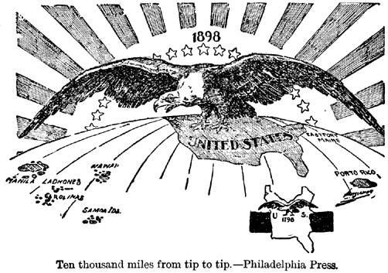
Causes of American Imperialism
Imperialism:

Global Competition | Military Strength
New Markets | Cultural Superiority

