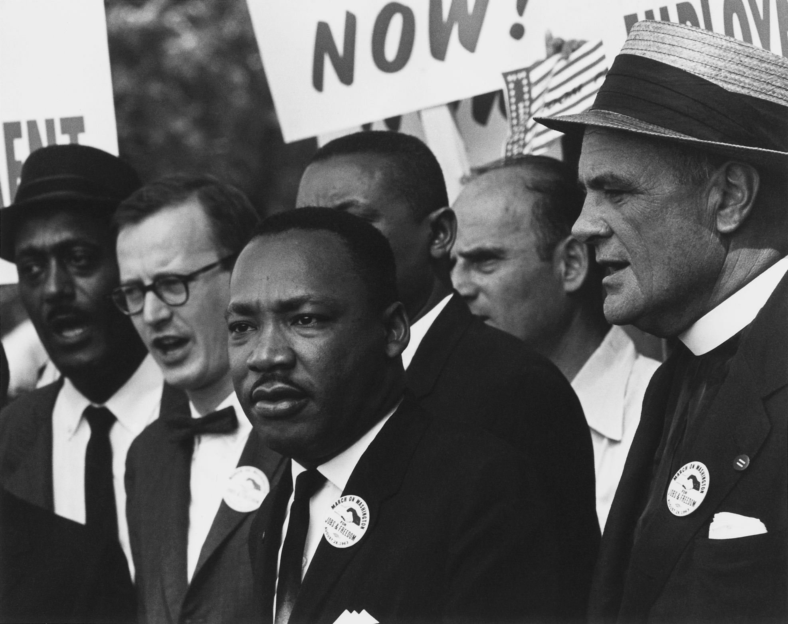
Civil Rights Scrapbook Lesson Plan
The year is 1969 and you’ve lived in the height of the Civil Rights Movement. You have been collecting items, photographs, and documents from the time and you are putting them together in a scrapbook.
You must have one page representing each of the following events:
- Brown v. the Board
- Montgomery Bus Boycott
- Little Rock Nine
- Sit-Ins
- Freedom Rides
- Integration of the Universities
- Children’s March in Birmingham
- March on Washington
- Freedom Summer
- Selma March
On each page of the scrapbook you must have AT LEAST four items. It may contain pictures, newspaper clippings, photographs, speeches, document excerpts, or anything else relevant to the time period. Everything in your scrapbook MUST have a caption or explanation to accompany it. This includes all pictures, items, etc.

Rubric
Requirements | Points Possible | Points Earned
Ten events included | 10
Appropriate number of sources per page | 10
Captions included, grammatical, and accurate | 20
Variety of sources included | 5
Creativity, Neatness, Apparent Effort | 5
TOTAL | 50

