Name Class Period Date

Colonial America Research Project
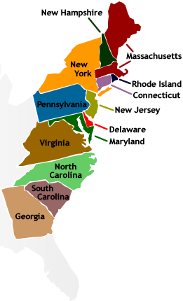
Congratulations! After an extensive search by the Smithsonian American History Museum, you have been chosen to design an exhibit on one of the thirteen colonies for a larger museum exhibit on Colonial America. Before the museum can accept your design, however, it is required that you complete a mock-up in a PowerPoint presentation.

Included in your exhibit must be the following information:

- Date of colonization
- Nation or Group that colonized the area and why.
- What other groups of people and/or ethnicities settled there and where? What was the estimated population?
- What it a Royal or Proprietary colony?
- Type of government of the colony
- Short history of the colony up to 1763 (any important or notable events/people)
- The physical features of the colony (geography, climate, etc)
- Main industry and/or agriculture products
- The group of colonies it belonged to – New England, Middle, or Southern
- Religion of most of the colonist and how it affected the people who lived in the colony
- Native Americans groups present in the area and their relationship with the colonists

Additionally, you should include:
- Pictures and/or artifacts to representing above topics.
- A map of the colony including major towns

Your mock-up should be well put together, attractive, and professional.

After all mock-ups PowerPoints are completed, Smithsonian management will set up a sample online exhibit in which you will be able to observe and take notes on the other colony mock-ups, after which you will receive an assessment on their quality and content.

Good luck!

Colony Assigned:

Due Date:

Virginia
Massachusetts
Maryland
Connecticut
Rhode Island
Delaware
North Carolina
South Carolina
New Jersey
New York
Pennsylvania
Georgia
New Hampshire

