Name Class Period Date
Effects of Imperialism
Directions: ANSWER ALL QUESTIONS ON A SEPARATE SHEET OF PAPER AND STAPLE IT TO THIS WORKSHEET.
Analyze the sources & videos in the worksheet below. When you see a QR code, scan it to watch a short video.
Roosevelt Corollary:
Scan the codes to learn more about Roosevelt’s Policy
Watch the videos & study the political cartoons to analyze TR’s foreign policy.

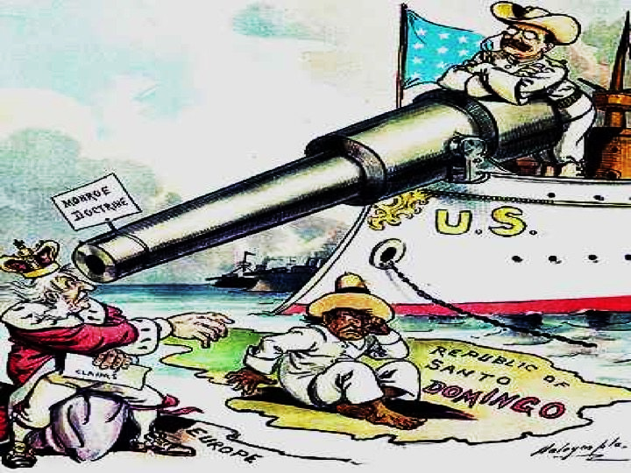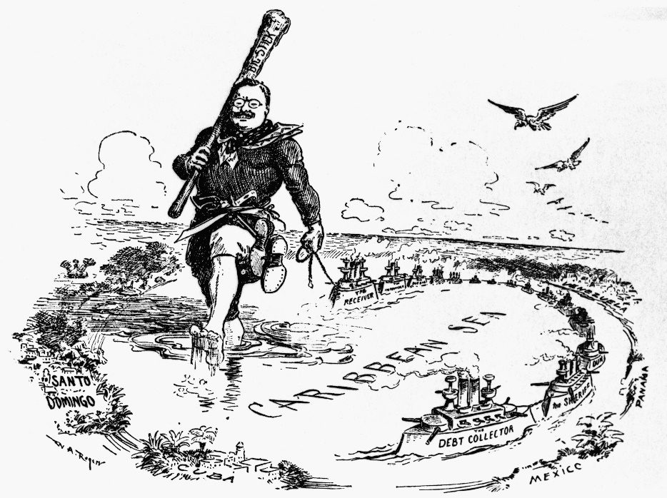
- What did Roosevelt mean by “Speak Softly and Carry a Big Stick”?
- Where did Roosevelt use this philosophy as president?
- What is the definition of the Roosevelt Corollary?
- According to the first political cartoon, what document is Roosevelt using defend Latin America? Against whom?
- What is Roosevelt’s “big stick” according to the second political cartoon (what is he using to influence Latin America)?

Panama Canal: use the chart, the cartoon, the video, and the map to answer the questions that follow. The chart shows the pros and cons of the two possible canal sites debated before Panama was chosen. The US construction of the canal cost $387 million and took 10 years.
Scan the code to learn more about the Panama Canal
Possible Canal Location | Nicaragua | Panama
Pros | - Recommended by 3 congressional commissions  - Lowest mountains in the region, less disease, large lake & navigable river  - Closer to the US  - 6 treaties give the US permission to dig | - Shorter distance between coasts  - Sit favored by Roosevelt  - Earlier French canal group site for sale
Cons | - Forcefully lobbied against by representatives of French canal group  - More volcanoes (although most extinct) | - No permission from Colombia to dig (who control Panama)  - More disease, higher mountains, fewer navigable rivers, and smaller lake  - Farther away from US
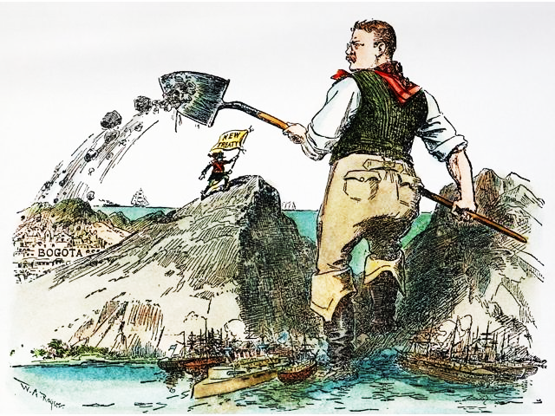
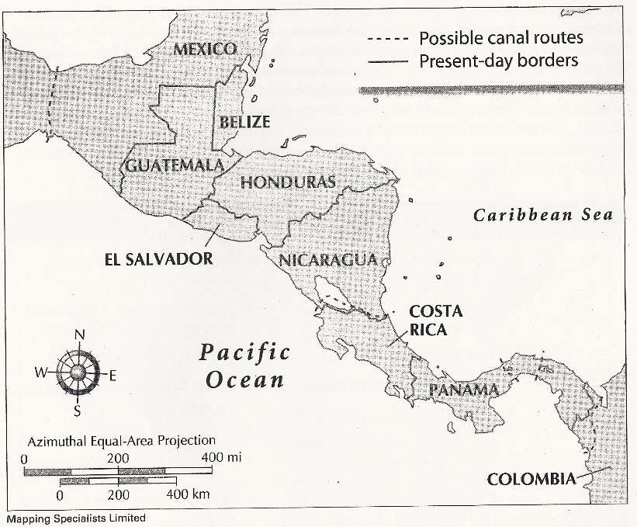
New Treaty
- Based on the chart, do you think Nicaragua or Panama is the better choice? Why do you think we ultimately selected Panama?
- As possible sites for the canal, what do Mexico, Costa Rica, Panama, and Colombia have in common?
- Given that Colombia didn’t want us to build the canal, how did we acquire the land? Was it a good decision? Why?
- Do you think the political cartoon is Pro- or Anti- Roosevelt? Why?
- What was the Panama Canal consider such a feat of engineering? How did US overcome some of the obstacles listed on the chart for building a canal in Panama?
- What were the long-term effects of the Panama Canal?
Dollar Diplomacy: use the graph and video to answer the questions
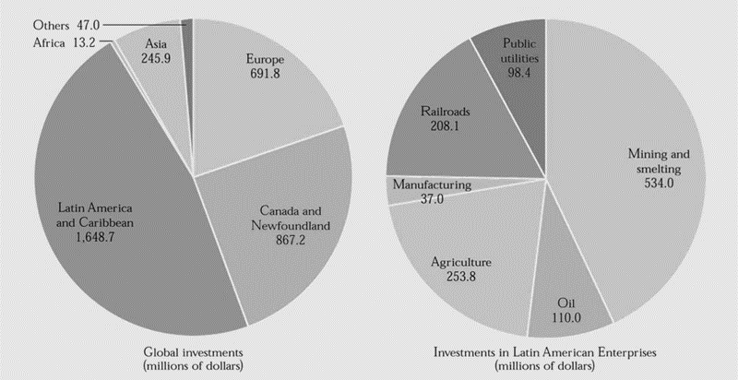

Scan the code to learn more about Dollar Diplomacy

- In what part of the world did the US put the most money in global investments?
- What were the top 2 Latin American enterprises in which American money was invested? Why might this be?
- What was the goal of Dollar Diplomacy & which president supported it?
- In what specific countries did the US intervene under this philosophy and why?
- What was the result of Dollar Diplomacy?
Open Door Policy: At the end of the 19th Century, China was weak and disorganized—a prime target for imperialist countries wanting more territory. Instead of competing against one another nations “carved” China into areas in which each nation would have privileged access to ports, trading, and other rights. The Chinese map became a patchwork of “spheres of influence.”
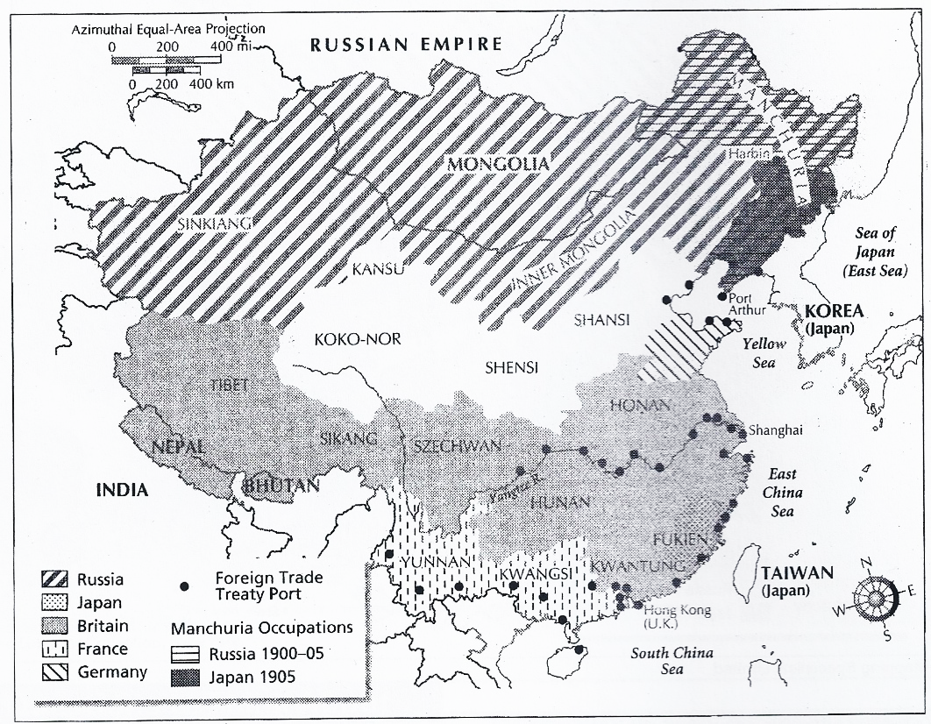
Scan the code to learn more about the Open Door Policy
- Which two European countries had the largest spheres of influence? Which had the smallest?
- What issue might the United States have with the “spheres of influence”?
- Describe the “Open Door Policy” that was insisted on by John Hay. Why would the US demand this?
- What was the result of the Open Door Policy?
- Can the Open Door Policy be considered Dollar Diplomacy? Why or why not?

Woodrow Wilson & Pancho Villa: use the videos, documents, & the cartoon to answer the questions
Scan the codes to learn more about Wilson’s diplomacy & US missions in Mexico

Scan the code to learn more about Pancho Villa
- What does Wilson mean by Missionary Diplomacy?
- Why did Wilson refuse to recognize Huerta’s government?
- Why did the US cross into Mexico’s borders?
- How does the political cartoon represent Missionary Diplomacy?
- How does Pancho Villa see himself? How do his men view him?
- In your opinion, did Wilson make the right choice to go after Pancho Villa? Why or why not?

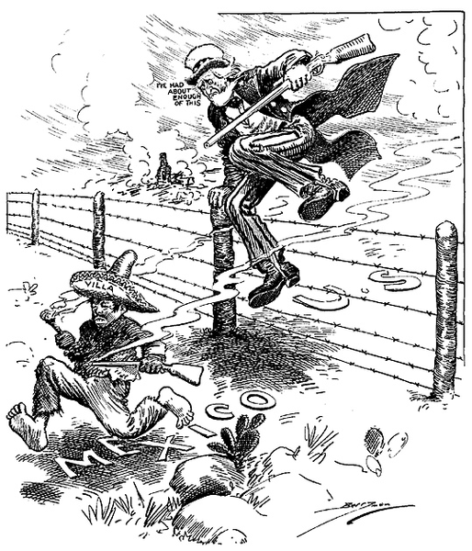

I've Had About Enough of This

Insular Cases and Modern Effects of Imperialism: Watch the video to answer the questions below. Fair warning: this video is PG-13, but it has been edited.

- What did the Insular Cases decide for US Territories?
- When have they been cited in recent history?
- How are the US territories of Guam and American Samoa affected today by the Age of Imperialism?

