**Foreign Relations Problems After WWII**

# Solution

**Problem (s)**

# Topic / Area

Eastern Europe and Turkey and Greece

The Economy and Infrastructure of Europe After WWII

West Berlin, Germany

**Alliances**

**Chinese Nationalists**

Leader

Policies

Popular Reaction

**Chinese Communists**

Leader

Policies

Popular Reaction

**Chinese Civil War**

US Involvement

Outcome

American Reaction

**Korea: Background**

1910-1945: Korea is a colony of . At the end of WWII Japanese troops north of the 38th parallel surrendered to , while Japanese troops south of the 18th parallel surrendered to .

**Two Koreas After WWII**

**North Korea South Korea**

Form of government: Form of government:

Leader Leader

Superpower allegiance: Superpower allegiance:

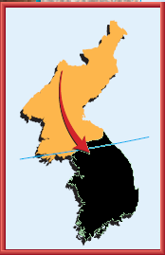**The Korean War (1950-1953)**

Date:

Aggressor:

Action:

Result:

Date:

Aggressor:

Action:

Result:

Date:

Aggressor:

Action:

Result:

Date:

Aggressor:

Action:

Result:

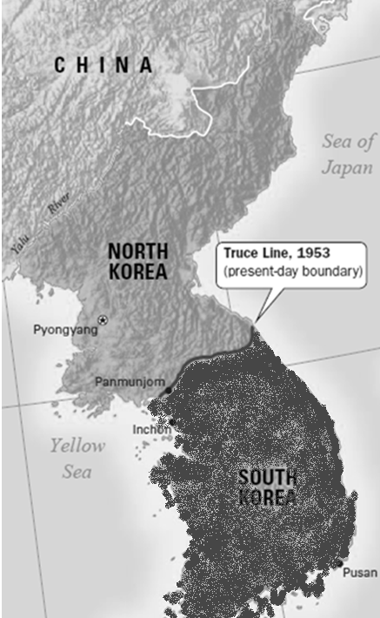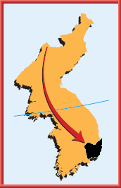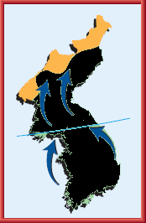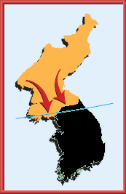

Brinkmanship& Cold War Foreign Policy:

Going to the Edge of Nuclear War

M.a.d.:

Goal:

Result:

C:\Documents and Settings\rjones9\Local Settings\Temporary Internet Files\Content.IE5\8SN9DPII\MC900078628[1].wmf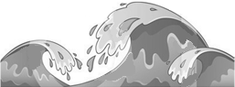

**The Hungarian Crisis**

**Sputnik**

**Suez Canal**

**Eisenhower Doctrine**

**U-2 Incident**

**Covert Affairs: The CIA**

**Domestic Problems After WWII**

# Topic / Area

**Problem (s)**

# Solution

* Loyalty Review Board:
* HUAC / Hollywood Ten:
* Alger Hiss:
* The Rosenbergs:
* McCarthyism:

**Fear of Spies and Communists**

**Returning WWII**

**Veterans**

# Topic / Area

**Problem (s)**

# Solution

## Housing

## Labor Strikes

## Civil Rights