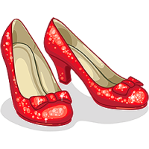

## Connections Between Populism and *The Wizard of Oz*

Oz:

Dorothy: The Tin Man:

The Wicked Witches of East & West: The Scarecrow:

The Munchkins: The Lion:

The Yellow Brick Road: The Wizard:

Dorothy’s slippers: The Emerald City:

**Leads to the formation of the “people’s party” or the Populist Party**

**Populist:**

* Members:
* Wanted:
* Nominate:

# Election of 1896

**Republicans:**

* Members:

**Outcome:**

# Railroads

.

# Debts

**Farmers in the Gilded Age**

**had TWO problems**