President |  | Foreign Policy Philosophy | Specific Examples/Events
William McKinley  (1897-1901) | 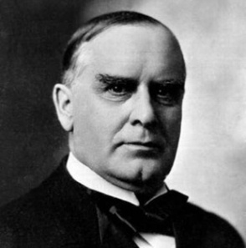
Theodore Roosevelt  (1901-1909) | 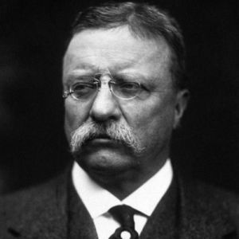
William H. Taft  (1909-1913) | 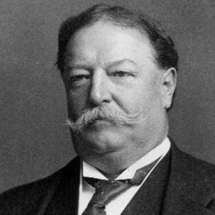
Woodrow Wilson  (1913-1921) | 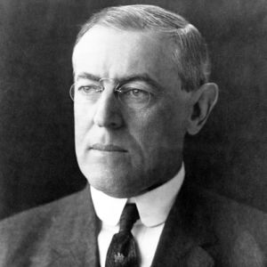
Turn of the Century Foreign Policy

