A PROCLAMATION – APRIL 22, 1793
By the President of the United States of America
A Proclamation
Whereas it appears that a state of war exists between Austria, Prussia, Sardinia, Great Britain, and the United Netherlands of the one part and France on the other, and the duty and interest of the United States require that they should with sincerity and good faith adopt and pursue a conduct friendly and impartial toward the belligerent powers:
I have therefore thought fit by these presents to declare the disposition of the United States to observe the conduct aforesaid toward those powers respectively, and to exhort and warn the citizens of the United States carefully to avoid all acts and proceedings whatsoever which may in any manner tend to contravene such disposition.
And I do hereby also make known that whosoever of the citizens of the United States shall render himself liable to punishment or forfeiture under the law of nations by committing, aiding, or abetting hostilities against any of the said powers, or by carrying to any of them those articles which are deemed contraband by the modern usage of nations, will not receive the protection of the United States against such punishment or forfeiture;
GO. WASHINGTON.

- How did President Washington respond to Citizen Genet’s request for American assistance in the French Revolutionary Wars?

- Why did he decide this way?

- Was this the right decision? Explain your answer.

A PROCLAMATION – APRIL 22, 1793
By the President of the United States of America
A Proclamation
Whereas it appears that a state of war exists between Austria, Prussia, Sardinia, Great Britain, and the United Netherlands of the one part and France on the other, and the duty and interest of the United States require that they should with sincerity and good faith adopt and pursue a conduct friendly and impartial toward the belligerent powers:
I have therefore thought fit by these presents to declare the disposition of the United States to observe the conduct aforesaid toward those powers respectively, and to exhort and warn the citizens of the United States carefully to avoid all acts and proceedings whatsoever which may in any manner tend to contravene such disposition.
And I do hereby also make known that whosoever of the citizens of the United States shall render himself liable to punishment or forfeiture under the law of nations by committing, aiding, or abetting hostilities against any of the said powers, or by carrying to any of them those articles which are deemed contraband by the modern usage of nations, will not receive the protection of the United States against such punishment or forfeiture;
GO. WASHINGTON.

- How did President Washington respond to Citizen Genet’s request for American assistance in the French Revolutionary Wars?

- Why did he decide this way?

- Was this the right decision? Explain your answer.

American Indian Policy
George Washington became the first President of the new United States in 1789. Like other Americans at this time, he believed that Euro-American culture was more advanced than Indian culture. He believed that Indians would eventually assimilate into the dominant American culture. Washington and his cabinet began to view Indian policy as a branch of foreign policy and viewed Indian tribes as foreign nations.

Northwest Territory Indian Wars
After the American Revolution, the Northwest Territory was given to the Americans, however, the Indian nations there were not part of that treaty. Many leaders, especially Little Turtle and Blue Jacket, refused to recognize United States claims to the area northwest of the Ohio River. The British remained in possession of their Great Lakes forts, through which they continued to supply Native American allies with trade items and weapons in exchange for furs.

The Land Ordinance of 1785 gave encouragement to land speculators, surveyors, and settlers who sought to gain new land from the Native Americans who may or may not have had a claim to it. The Northwest Ordinance of 1787, passed by the US Congress under the Articles of Confederation, gave Native Americans title, under U.S. law, to enjoy whatever lands they lived on. It also encouraged the influx of U.S. settlers north of the Ohio River. Localized ambushes and engagements between those settlers and Natives continued. The failure of the 1789 Treaty of Fort Harmar to address underlying grievances between the two sides exacerbated the problems.

Native raids on both sides of the Ohio River resulted in increasing casualties. During the mid- and late-1780s, American settlers south of the Ohio River in Kentucky and travelers on and north of the Ohio River suffered approximately 1,500 casualties. Settlers retaliated with attacks on Natives.

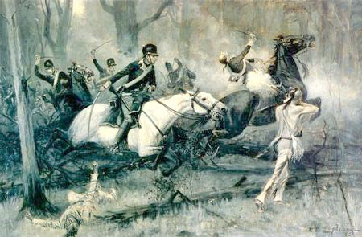
In 1790, President George Washington and Secretary of War Henry Knox ordered General Josiah Harmar to launch the Harmar Campaign, a major western offensive into the Shawnee and Miami country. In October 1790, a force of 1,453 men under Brigadier General Josiah Harmar was assembled near present-day Fort Wayne, Indiana, he however suffered a terrible defeat. Washington ordered Major General Arthur St. Clair to mount a more vigorous effort by summer 1791. St. Clair's force was camped near where Fort Recovery, Ohio is now, with weak defenses set up on the perimeter. A Native American force of about 2,000 warriors, led by Little Turtle, Blue Jacket, and Tecumseh, struck quickly. The American casualty rate was 69%, based on the deaths of 632 of the 920 soldiers and officers, with 264 wounded. Nearly all of the 200 unarmed camp followers were slaughtered, for a total of about 832 deaths—the highest United States losses in any of its battles with Natives.

After St Clair's disaster, Washington ordered General "Mad" Anthony Wayne to form a well-trained force and put an end to the situation. Wayne took command of the new Legion of the United States late in 1793. In June 1794, Little Turtle led an unsuccessful attack on Fort Recovery. Wayne's well-trained Legion advanced deeper into the territory of the Confederacy. Blue Jacket replaced Little Turtle in command, but the Native forces were defeated at the Battle of Fallen Timbers in August, a treaty was signed not long after in 1795.

Treaty of Greenville
Article 3 The general boundary line between the lands of the United States and the lands of the said Indian tribes, shall begin at the mouth of Cayahoga river, and run thence up the same to the portage, between that and the Tuscarawas branch of the Muskingum, thence down that branch to the crossing place above fort Lawrence, thence westerly to a fork of that branch of the Great Miami River, running into the Ohio, at or near which fork stood Loromie’s store, and where commences the portage between the Miami of the Ohio , and St. Mary’s river, which is a branch of the Miami which runs into lake Erie; thence a westerly course to fort Recovery, …the said Indians tribes do hereby cede and relinquish forever, all their claims to the lands lying eastwardly and southwardly of the general boundary line… And the said Indian tribes will also allow to the people of the
United States, the free use of the harbors and mouths of rivers along the lakes adjoining the Indian lands, for sheltering vessels and boats, and liberty to land their cargoes where necessary for their safety.

Article 4: …the United States (will) relinquish their claims to all other Indian lands …the United States (will) now deliver to the said Indian tribes a quantity of goods to the value of twenty thousand dollars, …; and henceforward every year, forever, the United States will deliver the useful goods, suited to the circumstances of the Indians, of the value of nine thousand five hundred dollars…

Article 5: …the Indian tribes who have a right to those lands, are quietly to enjoy them, hunting, planting, and
dwelling thereon, so long as they please; but when those tribes, or any of them, shall be disposed to sell their lands, they are to be sold only to the United States; and until such sale, the United States will protect all the said Indian tribes in the quiet enjoyment of their lands against all citizens of the United States, and against all other white persons who intrude upon the same.

Article 6: If any citizen of the United States, or any other white person or persons, shall presume to settle upon the lands now relinquished by the United States, such citizen or other person shall be out of the protection of the United States; and the Indian tribe, on whose land the settlement shall be made, may drive off the settler, or punish him in such manner as they shall think fit;

Article 7: The said tribes of Indians, parties to this treaty, shall be at liberty to hunt within the territory and lands which they have now ceded to the United States… so long as they demean themselves peaceably… Article 8 Trade shall be opened with the said Indian tribes…

Article 9: Lest the firm peace and friendship now established, should be interrupted by the misconduct of individuals, the United States, and the said Indian tribes agree, that for injuries done by individuals on either side, no private revenge or retaliation shall take place…

Article 10: All other treaties heretofore made between the United States, and the said Indian tribes, …that come within the purview of this treaty, shall henceforth cease and become void.

- What advantages did the Americans gain from this treaty? The Native Americans?

- How did the balance of power shift from before the war and after the treaty?

- What stipulations are put into place to ensure that both sides keep this treaty? (This may or may not be a trick question…)
Issues with Spain
Prior to the treaty, the western and southern borders of the United States had been a source of tension between Spain and the United States. The U.S. border extended to the Mississippi River, but its southern stretch remained in Spanish territory, and Spanish officials, reluctant to encourage U.S. trade and settlement in a strategic frontier area, kept the Mississippi River closed to American shipping. Moreover, both Spain and the United States claimed portions of the present-day states of Alabama and Mississippi, and earlier negotiations to resolve the territorial disputes had broken off inconclusively. The Spanish government maintained several forts in the disputed territories, and could also count on indigenous resistance to U.S. attempts to survey or encroach upon Native American lands. U.S. citizens from the southern states and frontier areas found Spanish policies restrictive, and wanted the U.S. Government to renegotiate its positions.

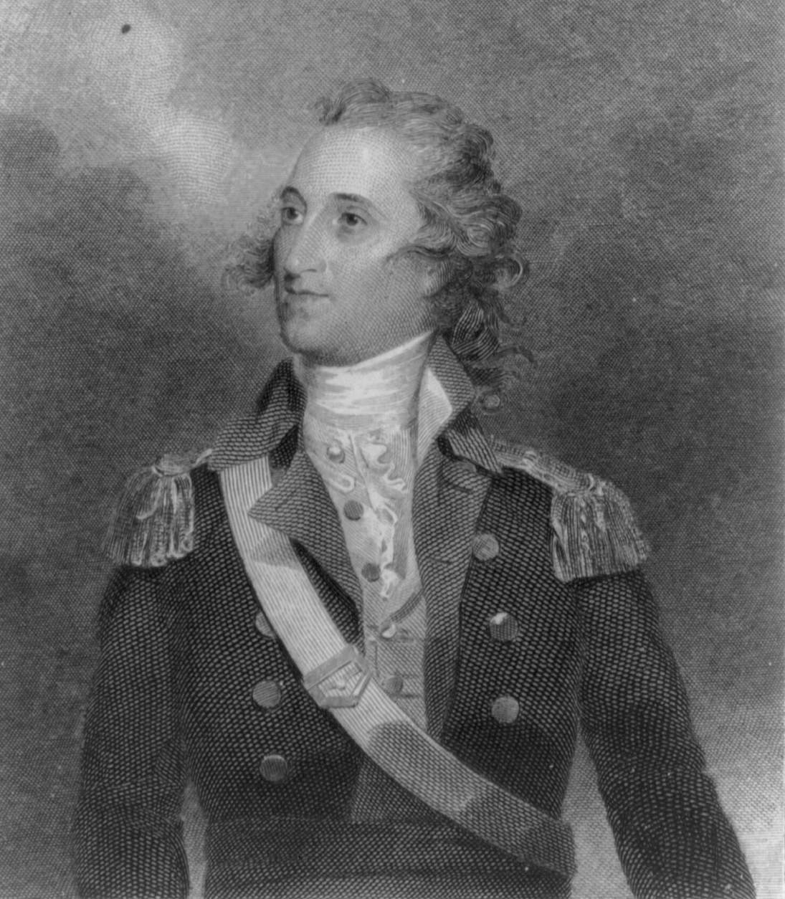
Spain and the French Revolution
Prior to 1789, Spanish policy had focused on keeping American trade and settlement in frontier areas to a minimum, and so neither Spanish colonial officials nor policymakers in Madrid were interested in granting the concessions that U.S. negotiators had attempted to obtain earlier. However, Spanish interests changed during the wars of the French Revolution. Spain joined the other European monarchies in war against France in 1793, but by 1794 Spanish forces experienced defeats in the Caribbean and Europe. Spanish King Charles IV, uninterested in managing political affairs, had earlier handed political and diplomatic responsibilities to his prime minister, Manuel de Godoy. Godoy sought to extract Spain from its alliance with its traditional enemy Great Britain, and to restore peace with France. Godoy’s policy was not without risks, as antagonizing the British would put Spanish colonies in the Americas at risk. Sensing the need for reconciliation, Godoy sent a request to the U.S. Government for a representative empowered to negotiate a new treaty. President George Washington selected South Carolinian Thomas Pinckney, who had been serving as United States minister to Great Britain.

Pinckney’s Treaty
ART. II: To prevent all disputes on the subject of the boundaries which separate the territories of the two High contracting Parties, it is hereby declared and agreed as follows: to wit: The Southern boundary of the United States which divides their territory from the Spanish Colonies of East and West Florida, shall be designated by a line beginning on the River Mississipi at the Northermost part of the thirty first degree of latitude North of the Equator, which from thence shall be drawn due East to the middle of the River Apalachicola or Catahouche, thence along the middle thereof to its junction with the Flint, thence straight to the head of St Mary's River, and thence down the middle there of to the Atlantic Occean. And it is agreed that if there should be any troops, Garrisons or settlements of either Party in the territory of the other according to the above mentioned boundaries, they shall be withdrawn from the said territory within the term of six months after the ratification of this treaty or sooner if it be possible and that they shall be permitted to take with them all the goods and effects which they possess….
ART. V: The two High contracting Parties shall by all the means in their power maintain peace and harmony among the several Indian Nations who inhabit the country adjacent to the lines and Rivers which by the proceeding Articles form the boundaries of the two Floridas; and the teeter to obtain this effect both Parties oblige themselves expressly to restrain by force all hostilities on the part of the Indian Nations living within their boundaries: so that Spain will notsuder her Indians to attack the Citizens of the United States, nor the Indians inhabiting their territory; nor will the United States permit these last mentioned Indians to commence hostilities against the Subjects of his Catholic Majesty, or his Indians in any manner whatever…
ART. XVI: This liberty of navigation and commerce shall extend to all kinds of merchandises excepting those only which are distinguished by the name of contraband… all other merchandises and things which are not comprehended and particularly mentioned in the foregoing enumeration of contraband goods: so that they may be transported and carried in the freest manner by the subjects of both parties…
- What are the decisions reached as part of Pinckney’s Treaty? How do they solve the aforesaid problems?

- What do you think Spain’s relationship with the US would be in the treaty’s aftermath? Might there be any cause for future tension?
PROBLEMS WITH ENGLAND
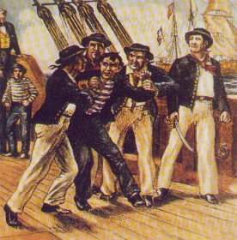
After Washington proclaimed America’s neutrality, British and American diplomats met to attempt to resolve several disputes left over from the Treaty of Paris (1783). Chief Justice John Jay represented the United States at the negotiations.

The American government had a number of issues it wanted dealt with:
- The British were still occupying a number of forts on U.S. territory in the Northwest Territory.*
- The British were continually capturing and impressing American sailors into British service
- American merchants wanted compensation for 250 merchant ships that had been confiscated during 1793 through 1794.*
- Southerners in the United States wanted monetary compensation for the slaves that the British Army had taken away from them during the Revolutionary War.
- Merchants in both America and in the Caribbean wanted the British West Indies to be reopened to American trade.*
- The British were believed to be aggravating Native American attacks on settlers in the West.

- In your opinion, which of the following demands is the most reasonable/unreasonable? Explain.

JAY TREATY

Jay Treaty, or Jay's Treaty, a treaty negotiated and signed in 1794 by John Jay, United States special envoy, and Lord William Grenville, British foreign secretary, to settle mutual grievances. Britain was at war with revolutionary France. The United States was neutral despite its alliance with France dating from the American Revolutionary War.

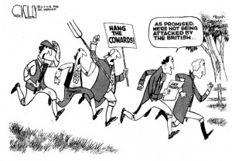
Britain agreed to evacuate military and trading posts in the Northwest Territory that it was holding in violation of the peace terms of 1783. Four joint commissions were created to settle boundary disputes and money claims. Britain made some commercial concessions toward freer trade with the United States. The United States agreed not to allow French privateers to seek refuge and supplies in its harbors. Both nations declared their support for free navigation on the Mississippi River.

REACTION TO THE JAY TREATY

Washington submitted the treaty to the United States Senate for ratification in June 1795. The treaty was unpopular at first, and gave Jefferson a platform to rally supporters into a new political party known as Jeffersonian Republicans or Democratic-Republicans. Jeffersonians were opposed to Britain, preferring support for France in the French Revolutionary Wars, and arguing a treaty with France from 1778 was still in effect. They looked at Britain as the center of aristocracy and the main threat to America's republican values. Therefore they denounced Hamilton and Jay (and even Washington) as monarchists who betrayed American values. They organized public protests against Jay and his treaty; one of their rallying cries went: Damn John Jay! Damn everyone that won't damn John Jay! Damn every one that won't put lights in his window and sit up all night damning John Jay!

- Why would many Americans favor France over Britain in the French Revolutionary Wars? __________________________________________________________________________________________________________________________________________________________________________________________________________

- Was Washington a hypocrite for supporting this treaty? Why or why not? _______________________________________________________________________________________________________________________________________________________________________________________________________________________________________________________________________________________________________________

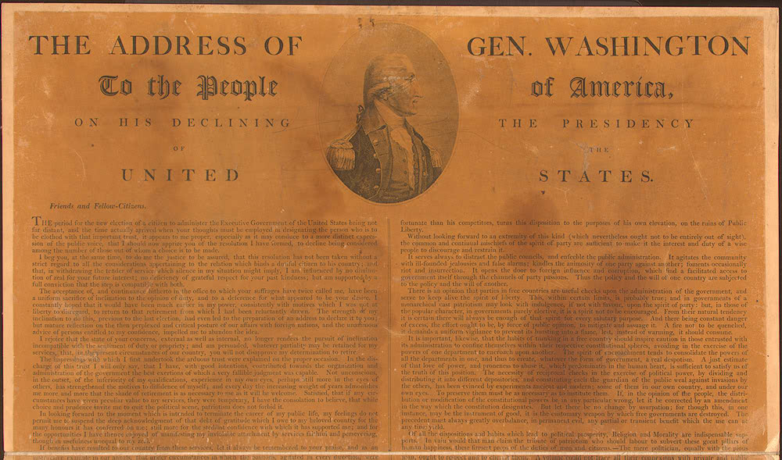
GEORGE WASHINGTON’S FAREWELL ADDRESS

By the end of his second term as president, the nation wanted Washington to run again for a third term. Creating another precedent that would last over 140 years, Washington refused and retired to his home at Mt. Vernon in Virginia. Before he left Washington, he sent his farewell address to all the nation’s newspapers. His address influenced American foreign policy for over a century.

The great rule of conduct for us in regard to foreign nations is in extending our commercial relations, to have with them as little political connection as possible. So far as we have already formed engagements, let them be fulfilled with perfect good faith. Here let us stop. Europe has a set of primary interests which to us have none; or a very remote relation. Hence she must be engaged in frequent controversies [arguments], the causes of which are essentially foreign to our concerns…

Our detached and distant situation invites and enables us to pursue a different course…

Why forego the advantages of so peculiar a situation? Why quit our own to stand upon foreign ground? Why, by interweaving our destiny with that of any part of Europe, entangle our peace and prosperity in the toils of European ambition, rivalship, interest…?

It is our true policy to steer clear of permanent alliances with any portion of the foreign world; so far, I mean, as we are now at liberty to do it;

- What type of foreign policy does Washington advocate for the United States? __________________________________________________________________________________________________________________________________________________________________________________________________________

- According to the speech, why is America is a unique situation when dealing with Europe? __________________________________________________________________________________________________________________________________________________________________________________________________________

- What effect did Washington believe that foreign affairs could have on domestic policies? __________________________________________________________________________________________________________________________________________________________________________________________________________

- How has US foreign policy departed from the principles Washington proposed? Explain. __________________________________________________________________________________________________________________________________________________________________________________________________________

- Would neutrality work today? Why or why not? _______________________________________________________________________________________________________________________________________________________________________________________________________________________________________________________________________________________________________________

