Name # Class Period Date

Stamp Act Make-Up Assignment
- First read through the “historical thinking chart.” This will give you the different steps on how to “read like a historian”
- Then you will read through the five documents which have opposing viewpoints on the “Stamp Act.” Read through these documents following the steps from the “historical thinking chart”
- Pull evidence from each document that shows either support or opposition to the stamp act, and list it in the chart below

Support of the Stamp Act | Opposition to the Stamp Act

Historical Reading Skills | Questions | Students should be able to . . . | Prompts
Sourcing | - Who wrote this?  - What is the author’s perspective?  - When was it written?  - Where was it written?  - Why was it written?  - Is it reliable? Why? Why not? | - Identify the author’s position on the historical event  - Identify and evaluate the author’s purpose in producing the document  - Hypothesize what the author will say before reading the document  - Evaluate the source’s  - trustworthiness by considering genre, audience, and purpose | - The author probably believes . . .  - I think the audience is . . .  - Based on the source information, I think the author might . . .  - I do/don’t trust this document because . . .
Contextualization | - When and where was the document created?  - What was different then? What was the same?  - How might the circumstances in which the document was created affect its content? | - Understand how context/background information influences the content of the document  - Recognize that documents are products of particular points in time | - Based on the background information, I understand this document differently because . . .  - The author might have been influenced by ___( context) . . .  - This document might not give me the whole picture because . . .
Corroboration | - What do other documents say?  - Do the documents agree? If not, why?  - What are other possible documents?  - What documents are most reliable? | - Establish what is probable by comparing documents to each other  - Recognize disparities between accounts | - The author agrees/disagrees with . . .  - These documents all agree/disagree about . . .  - Another document to  - consider might be . . .
Close Reading | - What claims does the author make?  - What evidence does the author use?  - What language (words, phrases, images, symbols) does the author use to persuade the document’s audience?  - How does the document’s language indicate the author’s perspective? | - Identify the author’s claims about an event  - Evaluate the evidence and reasoning the author uses to support claims  - Evaluate author’s word choice; understand that language is used deliberately | - I think the author chose these words in order to . . .  - The author is trying to convince me…  - The author claims . . .  - The evidence used to support the author’s claims is . . .

From a London Newspaper
Will Alfred wrote this public letter to Secretary Henry Seymour Conway. Conway was one of two of Britain’s Secretaries of State and was responsible for relations with the American colonies. The letter was first published in a London newspaper and then was published in the Boston Gazette Supplement on January 27, 1766, nearly three months after the Stamp Act went into effect.
From a late London Paper.
To Mr. Secretary Conway
There was an article lately in the news-papers, which well merits your utmost attention, and loudly calls for the interposition of government; I mean the insurrection at Boston in America to prevent the execution of the Stamp Act. Within these few years request have been the alarms, that the State was in danger, nor would I venture to affirm that they have been entirely without foundation; but government has never been in any perilous situation from any act of the Crown or its Ministers (whatever might have been the voice of a discontented faction) tho’ it may at this moment totter on the brink of distruction from the unbounded licentiousness of the people. It is of little consequence to enquire by what means this evil as arisen to such an enormous height; but it is a work well worthy of the best man, or the ablest Minister, to check its progress, and prevent its finally over turning the constitution. The spirit of riot has so long disturbed the repose of the island, has at length infected our colonies, and already begins to embroil there the administration of public affairs.—The fire is kindled, which it may be difficult to extinguish, and it is much to be dreaded, that the evil example of the rebellious Bostonites will be followed in all the other provinces. They have arose, you see, with violence; attacked several of the King’s servants, broke into and plundered their houses, and have committed the most daring outrages: They have even ventured to destroy the house of the Lieut. Governor, and have stripped him of all his effects, even to this cloaths: And in Rhode Island, terrified by the like tumultuous proceedings, some of the principal inhabitants have been forced to abandon their habitations, and betake themselves to the ships for shelter from the fury of the mob—How alarming are such acts of barbarity in a civilized country! How subversive of all order, and how inconfident with all government!...
The occasion of the riotous behavior of the Bostonites is peculiarly remarkable: Had the Parliament taxed their small beer an half penny a quart, the tax would then have been most severely felt; they would naturally have murmured; and an improper conduct on such an occasion had been less a matter of surprize; and perhaps ought less to have roused the indignation of government: But in the present case, the tax to be levied affects none of the necessaries of life; will never fall upon many of the poor; and will touch very gently and very seldom such of them as it may light upon: Even a very poor person cannot be much hurt by paying a shilling or eighteen pence when he is married, puts his son for apprentice to a trade, or when he makes his will. The tax on News-papers concerns only a very few—the common people don’t purchase news-papers. Is it not surprising then that the mob should be so much alarmed by the apprehension of a tax (by which they are to be so little affected) as to be guilty of such dreadful enormities, as the Bostonites have been, even before the tax is begun to be levied. I was expressing my wonder at this, when I was informed, that it was not the burthen of the tax to be raised, but the manner in which it was imposed, that created the discontent…

WILL ALFRED
Source: Will Alfred, “To Mr. Secretary Conway,” Boston Gazette Supplement, January 27, 1766.
Virginia Stamp Act Resolutions
Patrick Henry, at a meeting of the Virginia House of Burgesses, proposed seven resolutions against the Stamp Act. The first four resolutions were adopted and passed by the House of Burgesses. The Fifth resolution was repealed on the second day of the debates. Though resolutions six and seven were never passed by the House, all seven were widely reported in the colonial press, giving the impression that all passed the Virginia Assembly.
The following four resolves were adopted by the House of Burgesses on May 30, 1765:
Resolved, that the first adventurers and settlers of His Majesty's colony and dominion of Virginia brought with them and transmitted to their posterity, and all other His Majesty's subjects since inhabiting in this His Majesty's said colony, all the liberties, privileges, franchises, and immunities that have at any time been held, enjoyed, and possessed by the people of Great Britain.
Resolved, that by two royal charters, granted by King James I, the colonists aforesaid are declared entitled to all liberties, privileges, and immunities of denizens and natural subjects to all intents and purposes as if they had been abiding and born within the Realm of England.
Resolved, that the taxation of the people by themselves, or by persons chosen by themselves to represent them, who can only know what taxes the people are able to bear, or the easiest method of raising them, and must themselves be affected by every tax laid on the people, is the only security against a burdensome taxation, and the distinguishing characteristic of British freedom, without which the ancient constitution cannot exist.
Resolved, that His Majesty's liege people of this his most ancient and loyal colony have without interruption enjoyed the inestimable right of being governed by such laws, respecting their internal policy and taxation, as are derived from their own consent, with the approbation of their sovereign, or his substitute; and that the same has never been forfeited or yielded up, but has been constantly recognized by the kings and people of Great Britain.
The following version of the much-debated fifth resolution (which was not adopted) was found with Patrick Henry's will:
Resolved, therefor that the General Assembly of this Colony have the only and exclusive Right and Power to lay Taxes and Impositions upon the inhabitants of this Colony and that every Attempt to vest such Power in any person or persons whatsoever other than the General Assembly aforesaid has a manifest Tendency to destroy British as well as American Freedom.
The following two resolutions were not passed by the Virginia Assembly, but were reported in several newspapers:
Resolved, That His Majesty's liege people, the inhabitants of this Colony, are not bound to yield obedience to any law or ordinance whatever, designed to impose any taxation whatsoever upon them, other than the laws or ordinances of the General Assembly aforesaid.
Resolved, That any person who shall, by speaking or writing, assert or maintain that any person or persons other than the General Assembly of this Colony, have any right or power to impose or lay any taxation on the people here, shall be deemed an enemy to His Majesty's Colony.
Source: John Pendleton Kennedy, ed., Journals of the House of Burgesses of Virginia, 1761-1765 (Richmond, Va., 1907).

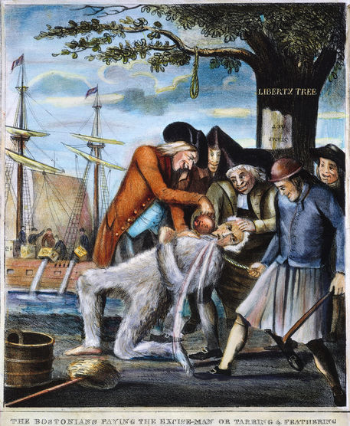
A 1774 British print depicted the tarring and feathering of Boston Commissioner of Customs John Malcolm. Tarring and feathering was a ritual of humiliation and public warning that stopped just short of serious injury. Victims included British officials such as Malcolm and American merchants who violated non-importation by importing British goods. Other forms of public humiliation included daubing victims’ homes with the contents of cesspits, or actual violence against property, such as the burning of stately homes and carriages. This anti-Patriot print showed Customs Commissioner Malcolm being attacked under the Liberty Tree by several Patriots, including a leather-aproned artisan, while the Boston Tea Party occurred in the background.
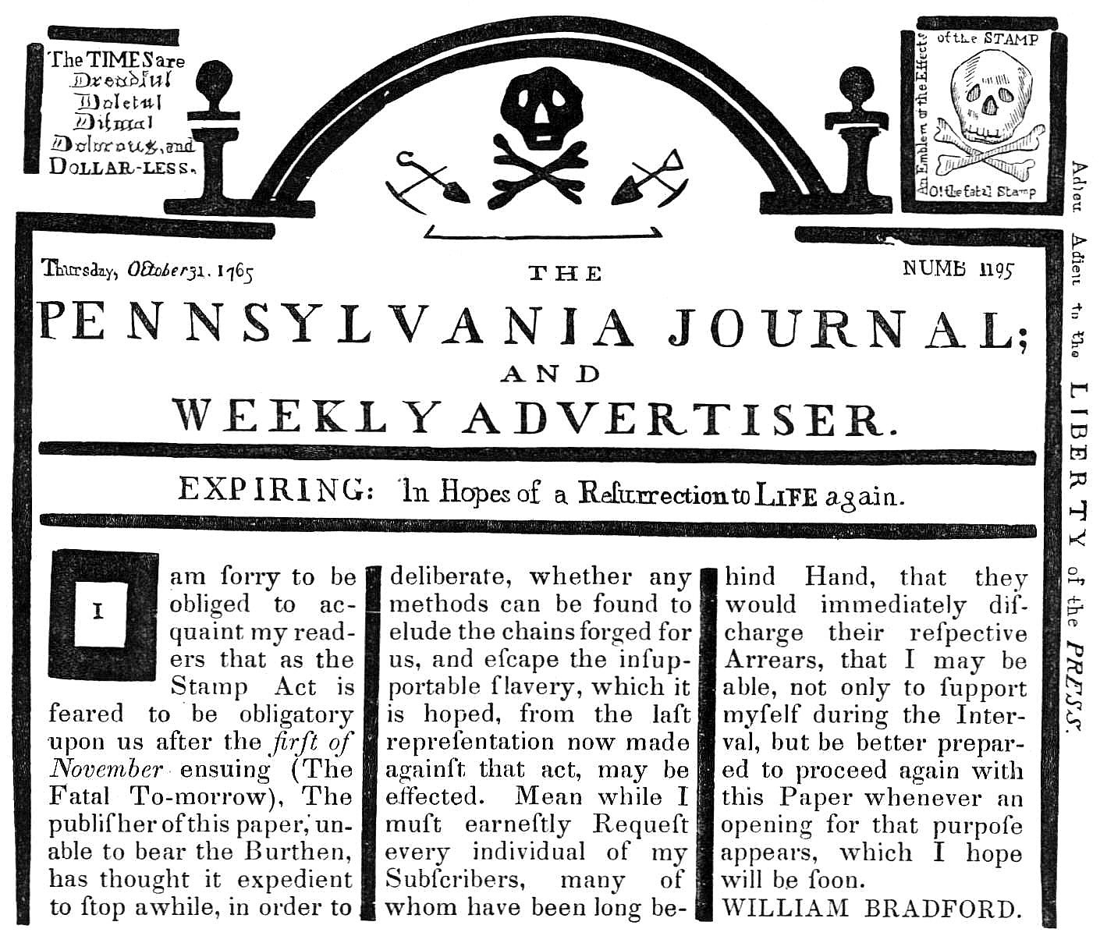
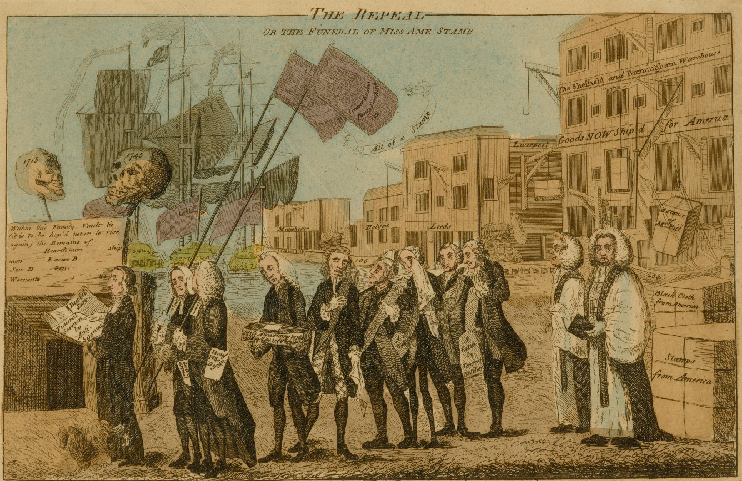
The Repeal, Or The Funeral Of Miss Ame-Stamp: Maker: Benjamin Wilson; Date: March 18, 1766
One of the most famous and popular of the political satires commenting on the Stamp Act, this print celebrates the end of the tax. An instant success, the print became one of the most copied satirical prints of the period. The print depicts a funeral procession composed of supporters of the act carrying a small coffin containing the remains of the bill toward an open vault. The vault has been prepared for the burial of all unjust acts that would alienate Englishmen. Leading the procession and preparing to deliver the funeral eulogy is the Reverend W. Scott, who is followed by the mourners: Grenville (carrying the coffin), Bute, Bedford, and Temple, some of the same Englishmen who were responsible for passing the act. By setting the action on a dock, Wilson is able to show the large unshipped cargoes destined for America that had accumulated during the period when the act was in force. Ships labeled "Conway," "Rockingham," and "Grafton," representing the Parliamentary leaders responsible for the repeal of the bill, now stand ready to carry the goods to America. Stamps just returned from America are also stacked on the wharf.

