Timeline of the American Revolution: Key
1763  10 February | Signing of the Treaty of Paris  Ending the Seven Year’s War, also known as the French and Indian War in North America. France ceded all mainland North American territories, except New Orleans, in order to retain her Caribbean sugar islands. Britain gained all territory east of the Mississippi River; Spain kept territory west of the Mississippi, but exchanged East and West Florida for Cuba.
1763  7 October | Proclamation of 1763  Wary of the cost of defending the colonies, George III prohibited all settlement west of the Appalachian mountains without guarantees of security from local Native American nations. The intervention in colonial affairs offended the thirteen colonies' claim to the exclusive right to govern lands to their west.
1764  5 April | Sugar Act  The first attempt to finance the defense of the colonies by the British Government. In order to deter smuggling and to encourage the production of British rum, taxes on molasses were dropped; a levy was placed on foreign Madeira wine and colonial exports of iron, lumber and other goods had to pass first through Britain and British customs. The Act established a Vice-Admiralty Court in Halifax, Nova Scotia to hear smuggling cases without jury and with the presumption of guilt. These measures led to widespread protest.
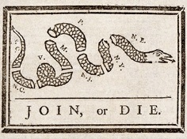  1765  22 March | Stamp Act  Seeking to defray some of the costs of garrisoning the colonies, Parliament required all legal documents, newspapers and pamphlets required to use watermarked, or 'stamped' paper, on which a levy was placed.
1765  15 May | Quartering Act  Colonial assemblies required to pay for supplies to British garrisons. The New York assembly argued that it could not be forced to comply.
1765  30 May | Virginian Resolution  The Virginian assembly refused to comply with the Stamp Act.
1765  7-25 October | Stamp Act Congress  Representatives from nine of the thirteen colonies declare the Stamp Act unconstitutional as it was a tax levied without their consent.
1766  18 March | Declaratory Act  Parliament finalizes the repeal of the Stamp Act, but declares that it has the right to tax colonies
1767  29 June | Townshend Revenue Act (Townshend Duties)  Duties on tea, glass, lead, paper and paint to help pay for the administration of the colonies, named after Charles Townshend, the Chancellor of the Exchequer. John Dickinson publishes Letter from a Philadelphian Farmer in protest. Colonial assemblies condemn taxation without representation.
1768  1 October | British troops arrive in Boston in response to political unrest.
1770  5 March | Boston Massacre  Angered by the presence of troops and Britain's colonial policy, a crowd began harassing a group of soldiers guarding the customs house; a soldier was knocked down by a snowball and discharged his musket, sparking a volley into the crowd which kills five civilians.
1770  12 April | Repeal of the Townshend Revenue Act
1772  10 June | Burning of the Gaspee  The revenue schooner Gaspee ran aground near Providence, Rhode Island and was burnt by locals angered by the enforcement of trade legislation.
1773  10 May | Tea Act  In an effort to support the ailing East India Company, Parliament exempted its tea from import duties and allowed the Company to sell its tea directly to the colonies. Americans resented what they saw as an indirect tax subsidizing a British company.
1773  16 December | Boston Tea Party  Angered by the Tea Acts, American patriots disguised as Mohawk Indians dump £9,000 of East India Company tea into the Boston harbor.
1774  May to June | Intolerable Acts  Four measures which stripped Massachusetts of self-government and judicial independence following the Boston Tea Party. The colonies responded with a general boycott of British goods.
1774  September | Continental Congress  Colonial delegates meet to organize opposition to the Intolerable Acts.
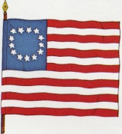  1775  19 April | Battles of Lexington and Concord  First engagements of the Revolutionary War between British troops and the Minutemen, who had been warned of the attack by Paul Revere.
1775  16 June | Continental Congress appoints George Washington commander-in-chief of Continental Army; issued $2 million bills of credit to fund the army.
1775  17 June | Battle of Bunker Hill  The first major battle of the War of Independence. Sir William Howe dislodged William Prescott's forces overlooking Boston at a cost of 1054 British casualties to the Americans' 367.
1775  5 July | Olive-Brach Petition  Congress endorses a proposal asking for recognition of American rights, the ending of the Intolerable Acts in exchange for a cease fire. George III rejected the proposal and on 23 August 1775 declared the colonies to be in open rebellion.
1776  9 January | Thomas Paine's Common Sense published anonymously in Philadelphia
1776  2 May | 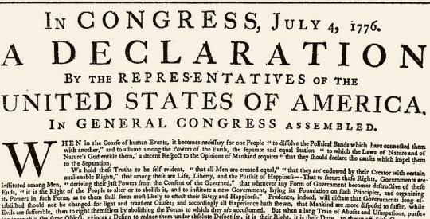  France provides covert aid to the Americans
1776  4 July | Continental Congress issues the Declaration of Independence
1775-1776  Winter | Invasion of Canada by Benedict Arnold
1776  26 December | Battle of Trenton, New Jersey, providing a boast to American morale.
1777  2-3 January | Battle of Princeton, New Jersey.  General Washington broke camp at Trenton to avoid a British advance, attacking the British rearguard and train near Princeton and then withdrawing to Morristown.
1777  13 October | British surrender of 5,700 troops at Saratoga.  Lacking supplies, 5,700 British, German and loyalist forces under Major General John Burgoyne surrender to Major General Horatio Gates in a turning point in the Revolutionary War.
1777-1778  Winter | American troops set up encampment at Valley Forge for the Winter. Starvation, disease, malnutrition, and exposure killed nearly 2,500 American soldiers by the end of February 1778
1778  6 February | France recognizes US Independence.
1781  1 March | Ratification of the Articles of Confederation
1781  5 September | 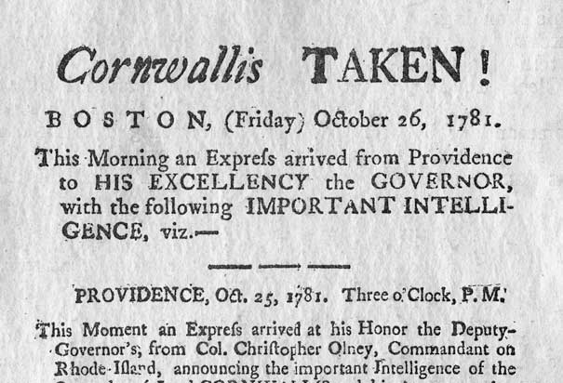  Battle of the Capes, denying British reinforcements or evacuation.
1781  18 October | Surrender of British forces under Cornwallis at Yorktown.
1782  5 March | British Government authorizes peace negotiations.
1783  3 September | Treaty of Paris, formally ending the Revolutionary War

Timeline of the American Revolution
1763  10 February | Signing of the Treaty of Paris  Ending the Seven Year’s War, also known as the in 1. North America. France ceded all mainland North American territories, except New Orleans, in order to retain her Caribbean sugar islands. Britain gained all territory east of the Mississippi River; Spain kept territory west of the Mississippi, but exchanged East and West Florida for Cuba.
1763  7 October | Proclamation of 1763  Wary of the cost of defending the colonies, George III prohibited all settlement west of the 2. mountains without guarantees of security from local Native American nations. The intervention in colonial affairs offended the thirteen colonies' claim to the exclusive right to govern lands to their west.
1764  5 April | Sugar Act  The first attempt to finance the defense of the colonies by the British Government. In order to deter smuggling and to encourage the production of British rum, taxes on molasses were dropped; a levy was placed on foreign Madeira wine and colonial exports of iron, lumber and other goods had to pass first through Britain and British customs. The Act established a Vice-Admiralty Court in Halifax, Nova Scotia to hear smuggling cases without jury and with the presumption of guilt. These measures led to widespread protest.
1765  22 March | 3. Act  Seeking to defray some of the costs of garrisoning the colonies, Parliament required all legal documents, newspapers and pamphlets required to use watermarked, or 'stamped' paper, on which a levy was placed.
1765  15 May | Quartering Act  Colonial assemblies required to pay for supplies to British garrisons. The New York assembly argued that it could not be forced to comply.
1765  30 May | Virginian Stamp Act Resolution  The Virginian assembly refused to comply with the Stamp Act.
1765  7-25 October | Stamp Act Congress  Representatives from nine of the thirteen colonies declare the Stamp Act unconstitutional as it was a tax levied without their 4. in British Parliament.
1766  18 March | Declaratory Act  Parliament finalizes the 5. of the Stamp Act, but declares that it has the right to 6. colonies
1767  29 June | Townshend Revenue Act (Townshend Duties)  Duties on tea, glass, lead, paper and paint to help pay for the administration of the colonies, named after Charles Townshend, the Chancellor of the Exchequer. John Dickinson publishes Letter from a Philadelphian Farmer in protest. Colonial assemblies condemn taxation without representation.
1768  1 October | British troops arrive in Boston in response to political unrest.
1770  5 March | 7. .  Angered by the presence of troops and Britain's colonial policy, a crowd began harassing a group of soldiers guarding the customs house; a soldier was knocked down by a snowball and discharged his musket, sparking a volley into the crowd which kills five civilians.
1770  12 April | Repeal of the Townshend Revenue Act
1772  10 June | Burning of the Gaspee  The revenue schooner Gaspee ran aground near Providence, Rhode Island and was burnt by locals angered by the enforcement of trade legislation.
1773  10 May | 8. .  In an effort to support the ailing East India Company, Parliament exempted its tea from import duties and allowed the Company to sell its tea directly to the colonies. Americans resented what they saw as an indirect tax subsidizing a British company.
1773  16 December | 9. .  Angered by the Tea Acts, American patriots disguised as Mohawk Indians dump £9,000 of East India Company tea into the Boston harbor.
1774  May to June | Intolerable Acts  Four measures which stripped Massachusetts of 10. and judicial independence following the Boston Tea Party. The colonies responded with a general boycott of British goods.
1774  September | Continental Congress  Colonial delegates meet to organize opposition to the Intolerable Acts.
1775  19 April | Battles of 11. .  First engagements of the Revolutionary War between British troops and the Minutemen, who had been warned of the attack by Paul Revere.
1775  16 June | Continental Congress appoints 12. commander-in-chief of Continental Army; issued $2 million bills of credit to fund the army.
1775  17 June | Battle of 13. .  The first major battle of the War of Independence. Sir William Howe dislodged William Prescott's forces overlooking Boston at a cost of 1054 British casualties to the Americans' 367.
1775  5 July | 14. .  Congress endorses a proposal asking for recognition of American rights, the ending of the Intolerable Acts in exchange for a cease fire. George III rejected the proposal and on 23 August 1775 declared the colonies to be in open rebellion.
1776  9 January | Thomas Paine's 15. published anonymously in Philadelphia
1776  2 May | 16. provides covert aid to the Americans
1776  4 July | Continental Congress issues the 17. .
1775-1776  Winter | Invasion of Canada by 18. .
1776  26 December | Battle of 19. , New Jersey, providing a boast to American morale.
1777  2-3 January | Battle of 20. , New Jersey.  General Washington broke camp at Trenton to avoid a British advance, attacking the British rearguard and train near Princeton and then withdrawing to Morristown.
1777  13 October | British surrender of 5,700 troops at 21. .  Lacking supplies, 5,700 British, German and loyalist forces under Major General John Burgoyne surrender to Major General Horatio Gates in a turning point in the Revolutionary War.
1777-1778  Winter | American troops set up encampment at 22. for the Winter. Starvation, disease, malnutrition, and exposure killed nearly 2,500 American soldiers by the end of February 1778
1778  6 February | France recognizes US Independence.
1781  1 March | Ratification of the 23. .
1781  5 September | Battle of the Capes, denying British reinforcements or evacuation.
1781  18 October | Surrender of British forces under Cornwallis at 24. .
1782  5 March | British Government authorizes peace negotiations.
1783  3 September | 25. , formally ending the Revolutionary War
Word Bank

- Appalachian
- Articles of Confederation
- Benedict Arnold
- Boston Massacre
- Boston Tea Party
- Bunker Hill
- Common Sense
- Declaration of Independence
- France
- French and Indian War
- George Washington
- Lexington and Concord
- Olive-Branch Petition
- Princeton
- repeal
- representation
- Saratoga
- self-government
- Stamp Act
- tax
- Tea Act
- Treaty of Paris
- Trenton
- Valley Forge
- Yorktown

