Groups of the West

Group | Key Events | Key People | Government Policies/Legislation | Cultural Characteristics
Natives

Cowboys/Ranchers

Miners

Laborers/Workers

Farmers

Keys to Industry in the Gilded Age
Natural Resources
OIL:

Inventions
Steel

COAL:

IRON ORE:

TELEPHONE:

ELECTRICITY:

TYPEWRITER:

Playing Monopoly: The “Big Wigs” of the Gilded Age & Big Business

Carnegie

U.S. Steel

- Practices:

J.P. Morgan
RRds & bought U.S. Steel

- Practices:

Rockefeller

Standard Oil

- Practices:

Vanderbilt

Railroads
- Practices:

Pullman
Railroad Cars

- Practices:

Duke

Tobacco
- Practices:

Competing Philosophies:

Are these men heroic or evil?
Heroic: “Captains of Industry”

Evil: “Robber Barons”

Immigration of the Gilded Age
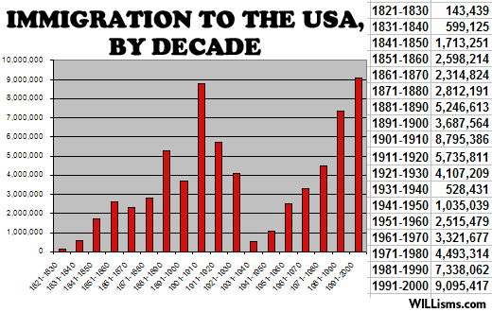
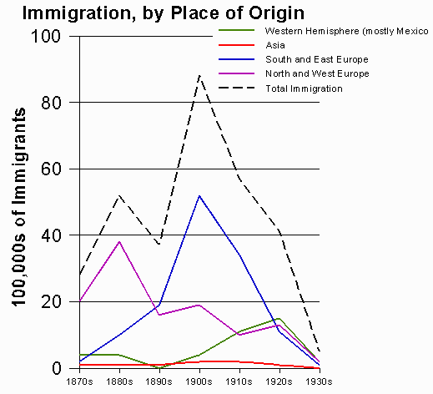
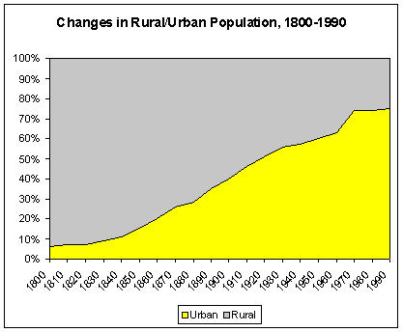
According to this chart, how many immigrants came into the United States between 1871 and 1910? ________________
According to this chart, where did most immigrants come from between the 1890s-1900s? _________________
According to this chart, what happened to the urban population between 1800 and 1900? _________________
Why are they coming to America?

Before 1890 (__________________________)
Mainly from _______ and _________ Europe
For Example:
Religion: ______________________
Quickly _________________, therefore _________ discrimination

Immigration in the US
After 1890 (_____________________________)
Mainly from _______ and _________ Europe
_________ America, ____________
Religion: __________________________
“Stand out”- ____________________________
_______________________________________

How are they coming to America?

When they arrived they landed in:
Ellis Island Angel Island

Nativists
- __________________feelings rampant
- Job _____________________
- Chinese Exclusion Act
  - ______________immigration for ____yrs
- Gentlemen’s agreement
  - Informal agreement w/ ______, Japan __________ immigration of ________ workers into US, US allows Japanese-Americans into ____________________
- ____________ pot and _______________
- _____________________ form
  - _______________ of similar homelands

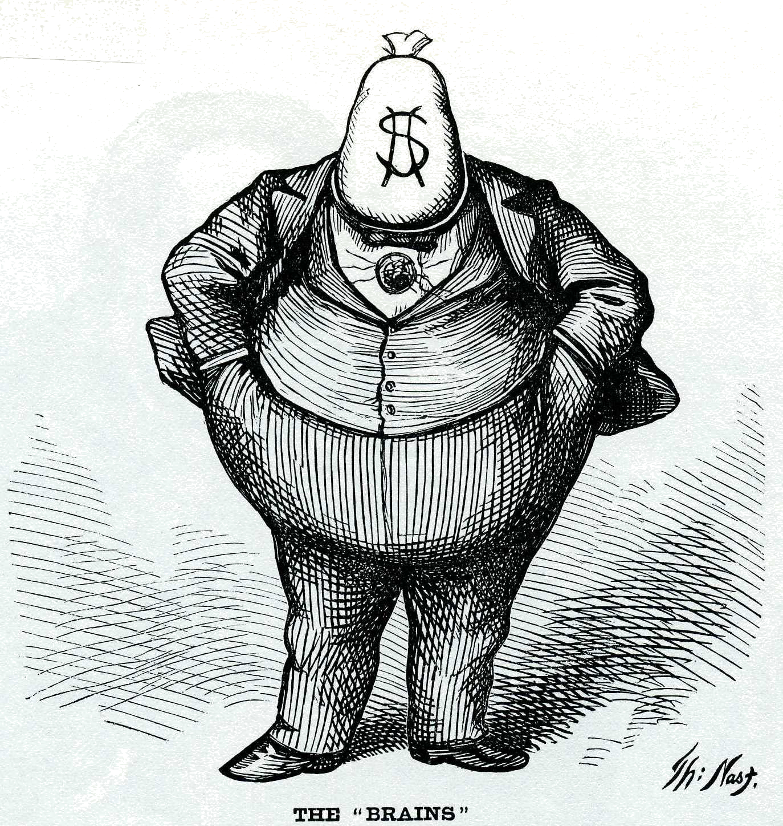

Political Machines
Definition:
How they got votes:

Immigrants:

Padding lists / fraud:
How they got money:

Graft / padding bills:

Bribes:
Example:

Organizational Structure:

Exposing Machines & Corruption

Once awareness is raised, there will be reform during the Progressive Era!!

Examples: secret ballots, city managers, commissioner systems, gov’t owned utilities, . . .
Labor Unions of the Gilded Age
National Labor Union
- Founded in 1866 by (iron worker)
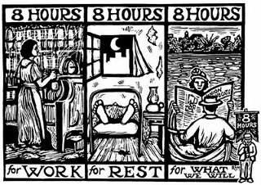
- Linked existing local unions.
- Wouldn’t admit workers.
- Persuaded Congress to legalize for government workers (1868)
- members at its peak.
Colored National Labor Union
- Led by
- Founded for workers
- Emphasized between management & labor, as well as political
- Disbanded in 1870s—members then join
Noble Order of Nights of Labor
- Founded in
- Officially open to all workers regardless of
- Supported for men & women
- Sought first, used strikes only as last resort
- 700,000 members at its peak (1886)
- Excluded workers
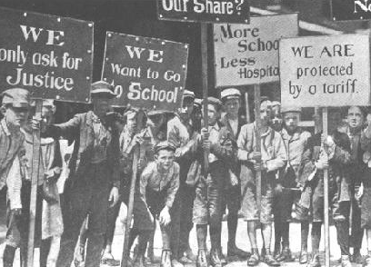
American Federation of Labor
- Founded by in 1886
- Open only (craft unionism)
- Focused on , but also used strikes
American Railway Union
- Led by
- Open to all laborers in the
- 150,000 members at its peak
International Workers of the World (Wobblies)
- Organized in 1905 and led by
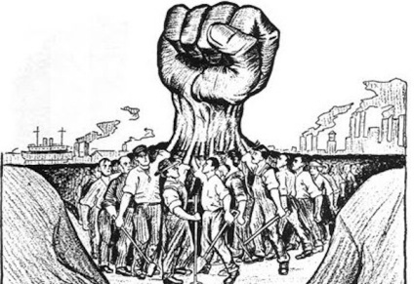
- Open to miners, lumberers, cannery workers, and dock workers ( )
- Turned to to achieve better conditions for workers
- Gave and sense of to unskilled workers

Causes of Urbanization Effects
1.

2.

Urban Problems Solutions

Labor / Management Conflicts

Cause

Conclusion

Conflict

Great Strike of 1877

Haymarket Affair

Homestead Strike

Pullman Strike

Triangle Factory Fire

Reform in the Gilded Age
 | Tariff:___________________________ | Monetary:_____________________ | Civil Service:______________________
Poor Want
Rich Want
Relevant Presidents
Result
Winner

