Unit 4 Vocabulary Activity – Group 1
_____________________________
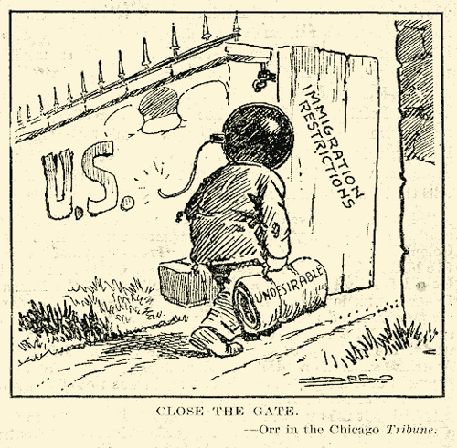
Group 1: quota, red scare, radical, normalcy
Directions: Match each term with a cartoon.
_____________________________
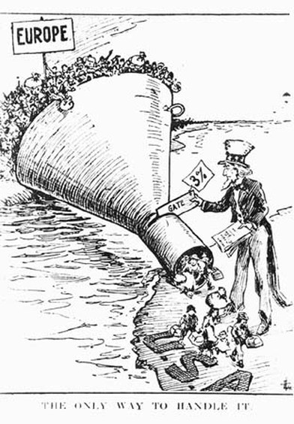

_____________________________
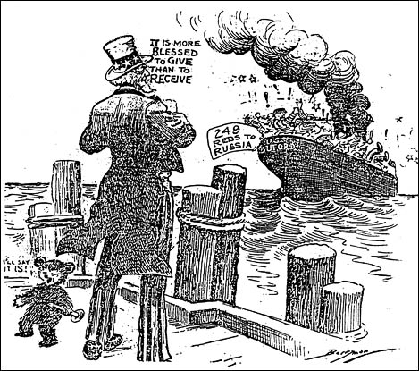
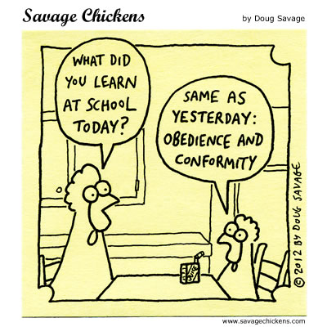
_____________________________

Unit 3 Vocabulary Activity – Group 2
Group 2: Harlem Renaissance, prohibition, speakeasy, bootlegger, flapper, double standard, fundamentalist
Directions: Complete the paragraph below by writing in the most appropriate term from the list above.
So, I started dating this new gal, Betty. She’s real cute, short hair, curvy, a ________________type. But man, her crazy family! They’re like bible-carrying __________________________ types who run moonshine on the side. They’re legit ______________________________. So, they have an interesting view on ______________________________. They don’t think you should drink alcohol, but that’s how they make their danged money, and the men folk are always “testing“ the product. Talk about a __________________________! I’m afraid to ask how they feel about race. I was gonna take Betty to see some fresh new jazz artists in the big city, they’re calling them part of the ______________________________. I don’t know what that’s all about, I just know Joe took his girl and he said they had a real good time. Betty would think it was the bees knees – I just fear her crazy family might not be so keen on the idea. Dames. Why do they have to be so complicated??
Unit 3 Vocabulary Activity – Group 3
Group 3: Standard of living, urban sprawl, superficial prosperity, installment plan
- Pick two words above that are similar but different. Write the words above each of the circles.
Complete the Venn diagram comparing and contrasting them:

- Pick the two remaining words from above. Write a complete sentence that uses them proper context.

Unit 3 Vocabulary Activity – Group 4
Group 4: stock, speculation, buying on margin, overproduction, bank run, foreclosures
Directions: Complete the paragraph below by writing in the most appropriate term from the list above.
I was farming from 1924-1927. But all the new fangled machines people bought (on borrowed money) led to more crops being planted and ________________________. So, nobody was making money since prices were so low. I moved to the city to be a butler for a rich family while my wife worked in a factory. I heard the rich guys talking about how you can buy a slip of paper that says you partly own a business, called a _________________. They were snapping up these investments as fast as possible, hoping they would grow in value in the future. It was simple _____________________________. It sure did sound promising, but I didn’t have any money to get in the game. I found out you could get a loan to buy stock. _______________________ was the answer, and I went to the bank right away. Of course, once the bubble burst, and it became clear no one was going to get squat for their stocks if they tried to sell; word got around that chumps like me weren’t going to be able to pay back the banks what they borrowed. I had put my house up as collateral to guarantee the loan, so I lost my house to _______________________. But, the bank couldn’t sell it, so they couldn’t turn it into the cash the people lined up at the banks were demanding. After the _________________________, the bank was forced to close their doors and all the customers who deposited their money there lost it. I couldn’t face my family, so I left. That’s how I started this hobo life.

Unit 3 Vocabulary Activity – Group 5
Group 5: dust bowl, rugged individualism, bread line, Hooverville, soup kitchen, shantytown
Directions: the two following images show the EFFECTS of two of the above terms. Write the word below the visual.
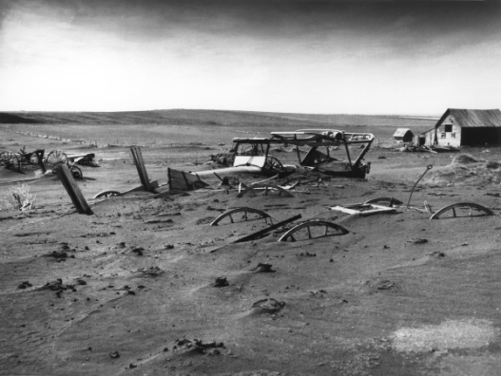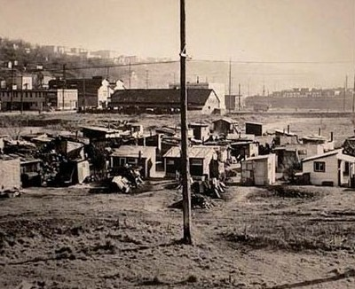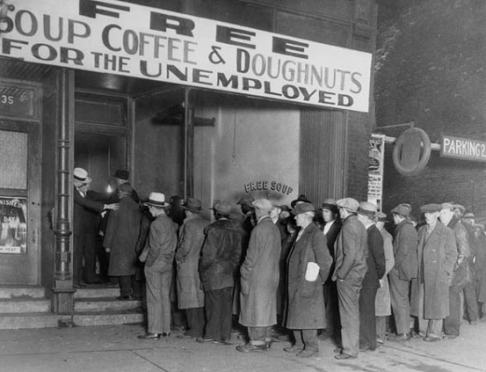

Effect of _______________________ Effect of ________________________________________
There are two other terms for the picture in the middle.
They are ___________________________ and ________________________________.
There are two other terms for the picture on the far right.
They are ___________________________ and ________________________________.

Unit 3 Vocabulary Activity – Group 6
Group 6: direct relief, price support, deficit, debt
- Pick two words above that are similar but different. Write the words above each of the circles. Complete the Venn diagram comparing and contrasting them. Use all four words

