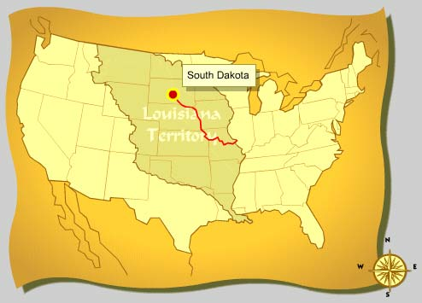
Name: ____________________________ Class: _______
Web Scavenger Hunt: Lewis & Clark
Part One
DIRECTIONS: Navigate to http://www.nationalgeographic.com/lewisandclark/index.html and select Begin Journey near the middle of the webpage. Now, use the numbers across the top to navigate through the journal log.
1 The Journey Begins
- How did Meriwether Lewis spend his time these first few weeks? William Clark? _________________________________________________________________________________________________________________________________________________________________________________________________________________________________________________________________________________.
2 Heading Into Danger?
- What were the first Indian tribes Lewis and Clark made contact with? ___________________________________
- What was the powerful Indian tribe that they were warned about? _____________________________________
3 Standoff With the Teton Sioux
- What happened when Lewis and Clark met the Teton Sioux? __________________________________________
______________________________________________________________________________________________________________________________________________________________________________________.
22 Given Up for Dead, Hailed as Heroes
- What was the average distance the expedition was traveling by the end of their trip? Name a place that is approximately that distance from your hometown. __________________________________________________
- How long did the expedition of Lewis and Clark take? ________________________________________________
Now, go back to 1 The Journey Begins page and select the Journals & Maps box located underneath the bottom right corner of the map. This webpage contains certain parts of the journal recorded by Lewis and Clark. Read the first journal entry written by William Clark on Sunday, May 13, 1804.
- What can you tell about the trip from this journal entry? ___________________________________________________________________________________________
___________________________________________________________________________________________.
Navigate back to the website’s homepage by selecting the Home box at the upper left hand corner of the webpage. Under the map, you will see a section called Expedition Records and More. Select the word Discoveries. (Use the categories to the left of the webpage to help you with the following questions)
- List the common names for two (2) plants that were discovered by the Lewis and Clark expedition.
___________________________________ _____________________________________
- List the common names for two (2) animals that were discovered by the Lewis and Clark expedition.
___________________________________ _____________________________________
- Name three (3) Indian tribes that Lewis and Clark made contact with.
___________________________________ _____________________________________
___________________________________

Part 2
DIRECTIONS: Navigate to http://edgate.com/lewisandclark/ and select Mapping the West, located near the top of the page along the website’s menu bar. Read each section to answer the following questions:
Mapping a New Territory
- President Thomas Jefferson and his supporters wanted to learn more about North America’s waterways, its inhabitants, its natural resources, and its possibilities for settlement by Americans. What was the name of this unexplored area of North America? ___________________________________________________________________________________________
Jefferson’s Instructions to Lewis
- What river did President Jefferson direct Lewis to explore?
___________________________________________________________________________________________
- What did President Jefferson hope that Lewis and Clark would find?
___________________________________________________________________________________________
Importance of Mapping
- Who did most of the actual surveying and mapmaking during and after the expedition?
___________________________________________________________________________________________
- Why was it important to President Jefferson that Lewis and Clark make an accurate map?
___________________________________________________________________________________________
Extra Credit
DIRECTIONS: Navigate to http://www.nationalgeographic.com/lewisandclark/index.html and scroll to the bottom of the page. Select link “plan your own expedition” under the heading Kids Activity. Scroll to read the instructions and choose an activity for Younger Xpeditioners or Older Xpeditioners.

