What does it mean to be American?
When you call yourself an American, what do you really mean? America is a different kind of country than most because in American there is a mixing of so many different cultures, religions, languages, and beliefs. The meaning of the term “American” has often changed over the decades. You will be answering the questions what it means to be American by looking at what others before you have said.
DIRECTIONS: In your group, read out loud a letter written by J. Hector St. John De Crévecoeur. You may choose one person in the group to read or break it up within your group. When you’ve finished, discuss and answer the following questions ON YOUR OWN SHEET OF PAPER about the author’s definition of what it means to be American. Then, look carefully at the painting provided. In your groups, discuss each painting by answering the questions below.

For each painting:
Describe the painting. What kinds of people do you see? What are they doing? What are the expressions on their faces? Are there any details that stand out at you? (Hint: be sure to look at the titles)

How do you feel when you look at this painting?

Do you relate to this painting? Explain.

What do you think this picture is trying to say about Americans? Do you agree or disagree with the message?

WHAT IS AN AMERICAN? By J. Hector St. John De Crévecoeur (c. 1782)
I WISH I could be acquainted with the feelings and thoughts which must agitate the heart and present themselves to the mind of an enlightened Englishman, when he first lands on this continent… He is arrived on a new continent; a modern society offers itself to his contemplation, different from what he had hitherto seen. It is not composed, as in Europe, of great lords who possess everything and of a herd of people who have nothing. Here are no aristocratical families, no courts, no kings, no bishops, no ecclesiastical dominion, no invisible power giving to a few a very visible one; no great manufacturers employing thousands, no great refinements of luxury. The rich and the poor are not so far removed from each other as they are in Europe. Some few towns excepted, we are all tillers of the earth, from Nova Scotia to West Florida. We are a people of cultivators, scattered over an immense territory communicating with each other by means of good roads and navigable rivers, united by the silken bands of mild government, all respecting the laws, without dreading their power, because they are equitable. We are all animated with the spirit of an industry which is unfettered and unrestrained, because each person works for himself. If he travels through our rural districts he views not the hostile castle, and the haughty mansion, contrasted with the clay-built hut and miserable cabin, where cattle and men help to keep each other warm, and dwell in meanness, smoke, and indigence. A pleasing uniformity of decent competence appears throughout our habitations. The meanest of our log-houses is a dry and comfortable habitation. Lawyer or merchant are the fairest titles our towns afford; that of a farmer is the only appellation of the rural inhabitants of our country. It must take some time ere he can reconcile himself to our dictionary, which is but short in words of dignity, and names of honor. There, on a Sunday, he sees a congregation of respectable farmers and their wives, all clad in neat homespun, well mounted, or riding in their own humble wagons. There is not among them an esquire, saving the unlettered magistrate. There he sees a parson as simple as his flock, a farmer who does not riot on the labour of others. We have no princes, for whom we toil, starve, and bleed: we are the most perfect society now existing in the world…
The next wish of this traveler will be to know whence came all these people? They are mixture of English, Scotch, Irish, French, Dutch, Germans, and Swedes. From this promiscuous breed, that race now called Americans have arisen…
What attachment can a poor European emigrant have for a country where he had nothing? The knowledge of the language, the love of a few kindred as poor as himself, were the only cords that tied him: his country is now that which gives him land, bread, protection, and consequence: Ubi panis ibi patria, is the motto of all emigrants. What then is the American, this new man? He is either an European, or the descendant of an European, hence that strange mixture of blood, which you will find in no other country. I could point out to you a family whose grandfather was an Englishman, whose wife was Dutch, whose son married a French woman, and whose present four sons have now four wives of different nations. He is an American, who leaving behind him all his ancient prejudices and manners, receives new ones from the new mode of life he has embraced, the new government he obeys, and the new rank he holds…The Americans were once scattered all over Europe; here they are incorporated into one of the finest systems of population which has ever appeared, and which will hereafter become distinct by the power of the different climates they inhabit. The American ought therefore to love this country much better than that wherein either he or his forefathers were born. Here the rewards of his industry follow with equal steps the progress of his labour; his labour is founded on the basis of nature, self-interest; can it want a stronger allurement? Wives and children, who before in vain demanded of him a morsel of bread, now, fat and frolicsome, gladly help their father to clear those fields whence exuberant crops are to arise to feed and to clothe them all; without any part being claimed, either by a despotic prince, a rich abbot, or a mighty lord. I lord religion demands but little of him; a small voluntary salary to the minister, and gratitude to God; can he refuse these? The American is a new man, who acts upon new principles; he must therefore entertain new ideas, and form new opinions. From involuntary idleness, servile dependence, penury, and useless labour, he has passed to toils of a very different nature, rewarded by ample subsistence. --This is an American.

Glossary:

Aristocratical—noble or titled family
Ecclesiastical—churchly or religious
Unfettered—free, unregulated
Indigence—poverty
Appellation—name or title
Penury—severe poverty
Ubi panis ibi patria—Latin for “Where there is bread, there is my country.”

Questions to consider:
- How does de Crévecoeur support his claim that America is the “most perfect society now existing in the world”?
- Does de Crévecoeur’s definition of what it means to be American still apply today?
- What positive qualities of American life would de Crévecoeur add if he were writing today?
- Do you agree or disagree with de Crévecoeur? Why or why not?

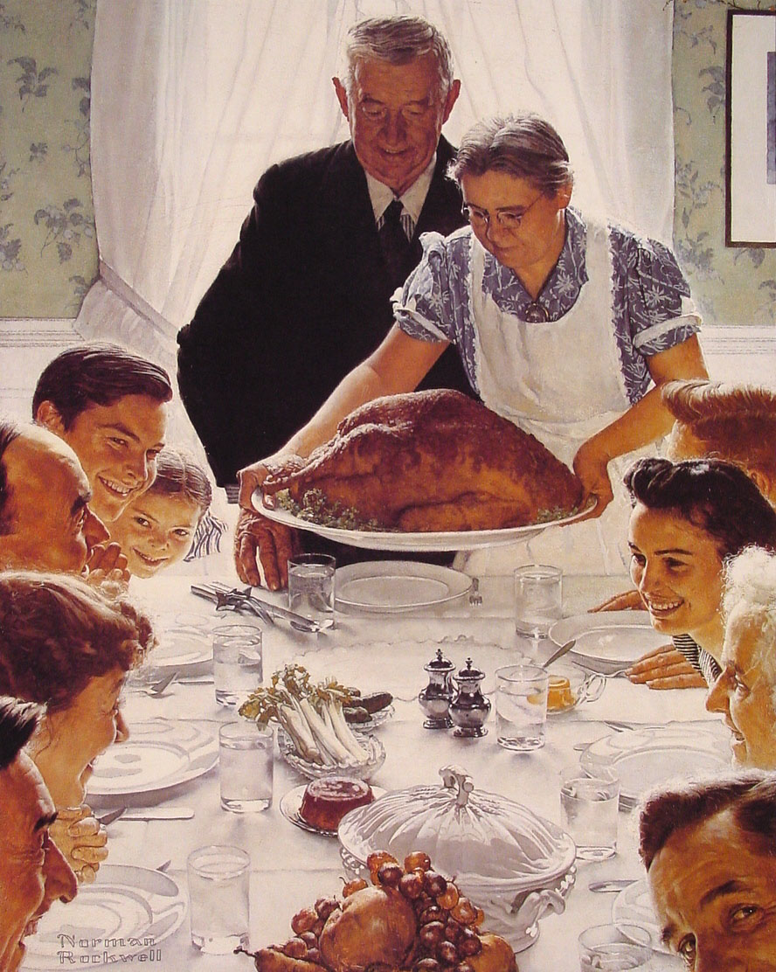Freedom from Want, Normal Rockwell

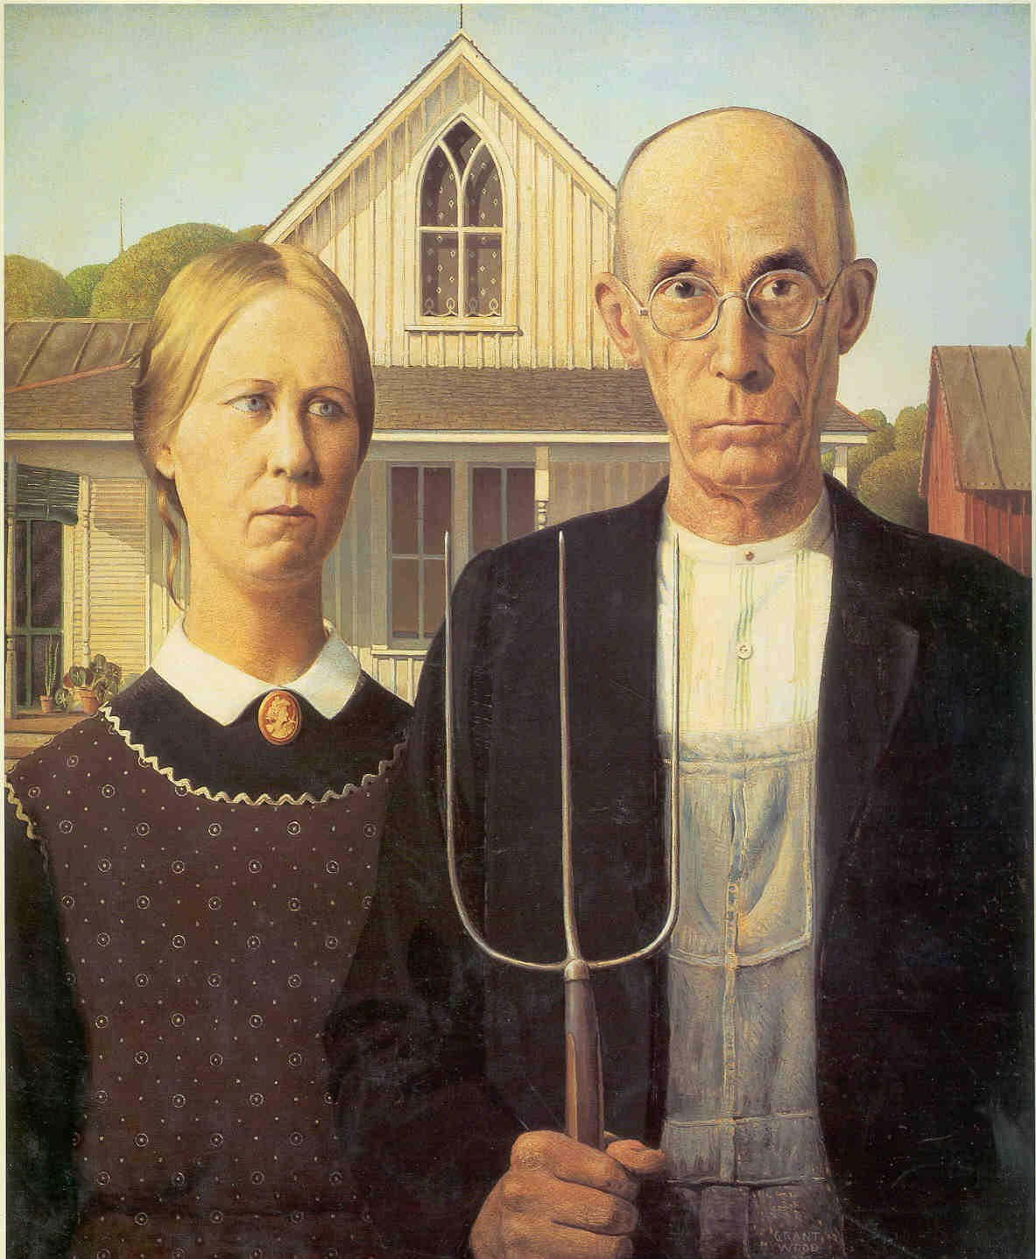
American Gothic, Grant Wood

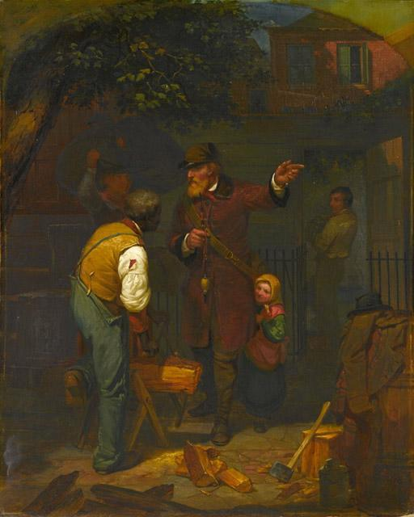
A German Immigrant Inquiring His Way, Charles Felix Blauvelt
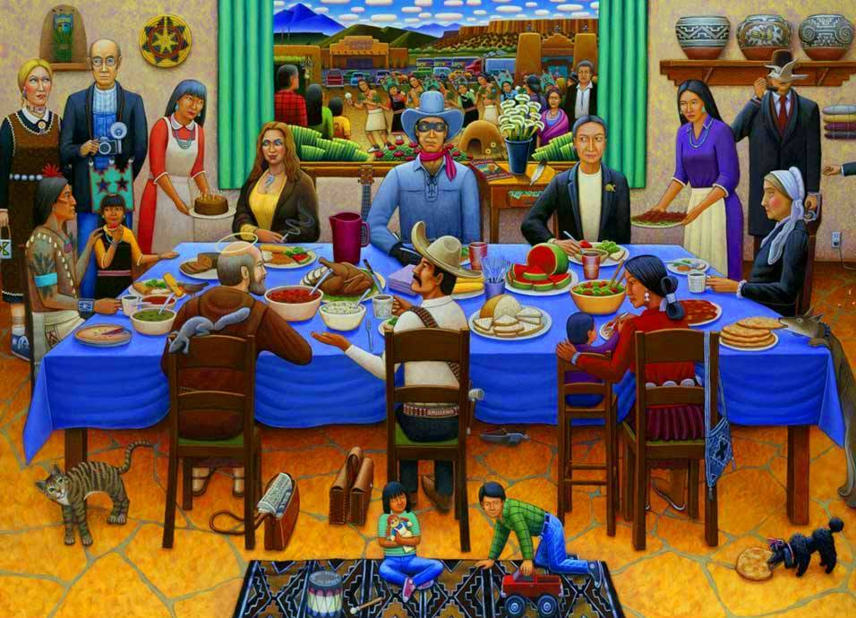
Pueblo Feast Day, David Bradley
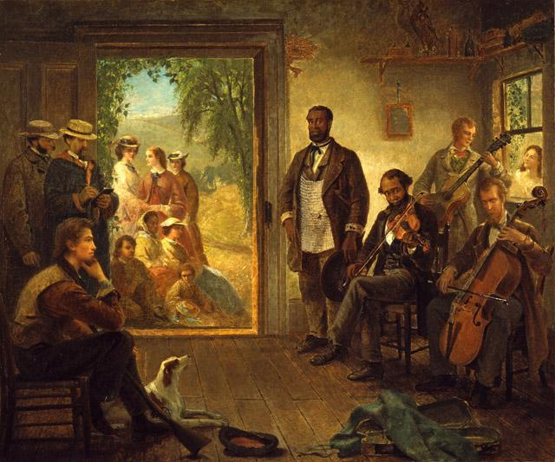

The Musicale, Barber Shop, Trenton Falls New York, Thomas Hicks
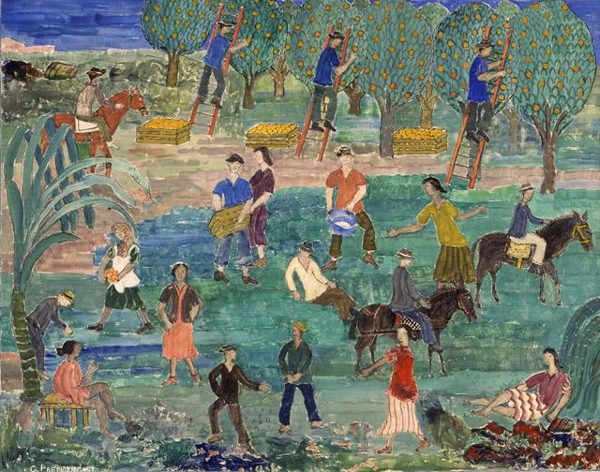
Orange Pickers, Florida, Charles James Prendergast
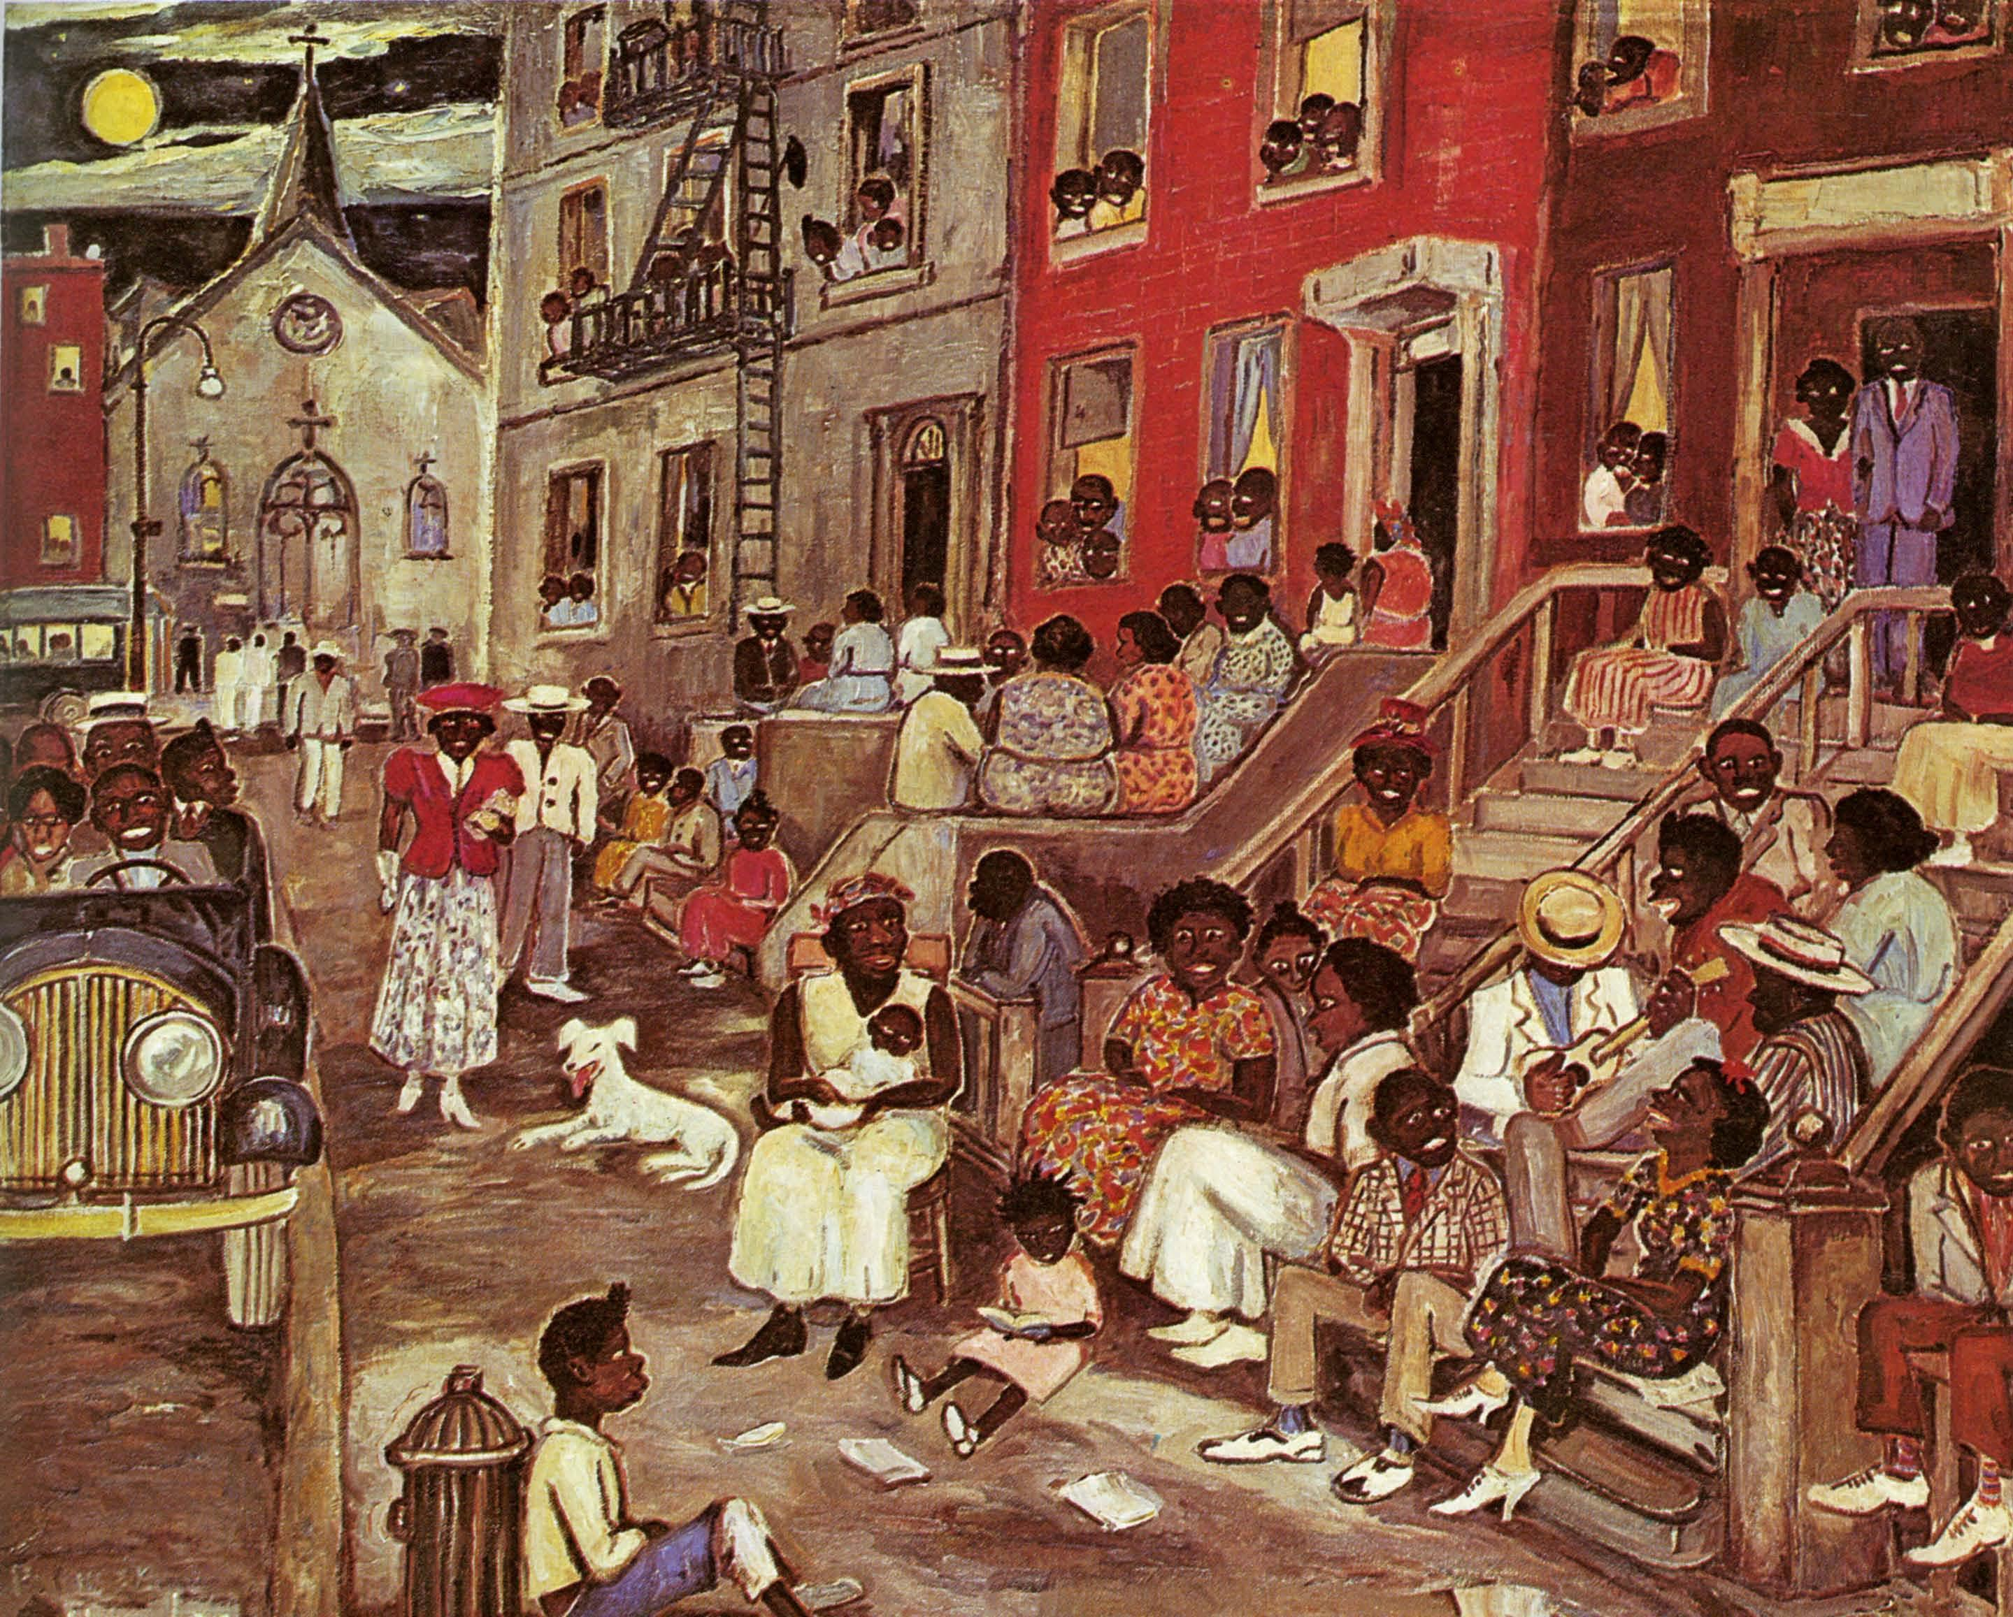
Midsummer Night in Harlem, Palmer Hayden

