Name Date _

WWII Cartoon Packet

1. What is appeasement?
2. Who was America (and Great Britain) trying to appease?
3. Why were we practicing appeasement?
4. What is isolationism?
5. Why did we want to be isolated?
6. What countries did Hitler take over at first?
7. What country did Japan take over? What did they do to the United States?
8. Who was the leader of Italy?
9. What is fascism?
10. How did the depression lead to WWII?
11. 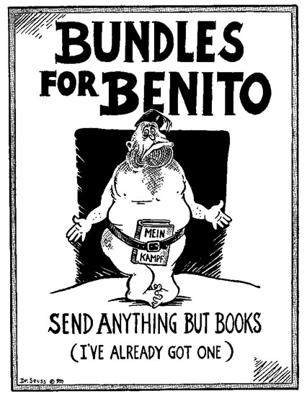Who is Benito?
12. What is the significance of the book in the cartoon?
13. What do you this is the message about Benito?

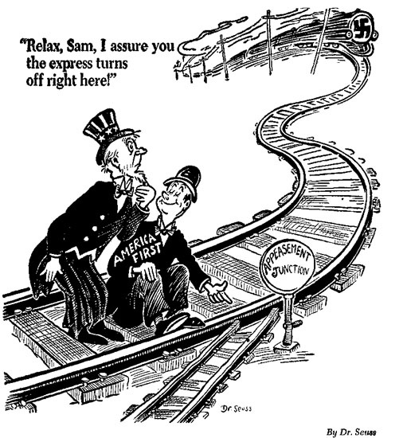

* 1. What is the problem with appeasement junction?
  2. Does it look like the train will change tracks when it gets to the Junction?
  3. If the train does not change tacks, what will happen to the man in the striped hat?

1. Who is the man in the stripped hat?
2. What does the train represent?

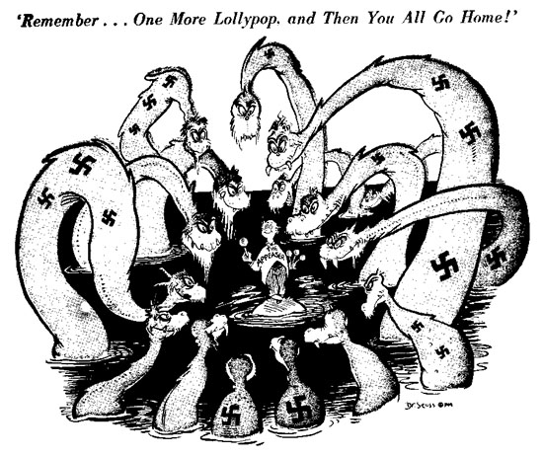

1. Who do the monsters represent?
2. Why did Hitler take over land in Europe?
3. What did the US do to stop him?
4. What did we think would happen if we let Hitler take some land?
5. How does this relate to the cartoon?

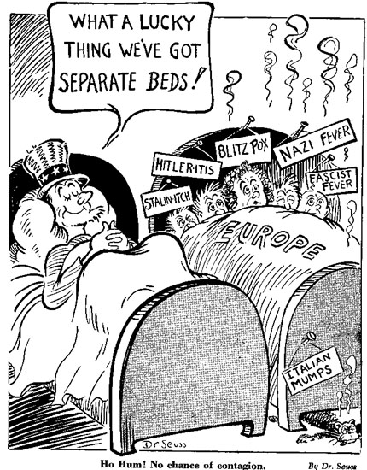

1. What do the two beds represent?

2. What illnesses are in the European bed?

3. Why does America think that they can't catch these diseases?

4. Do you think that America could catch the European diseases?

S. How does this relate to isolationism?

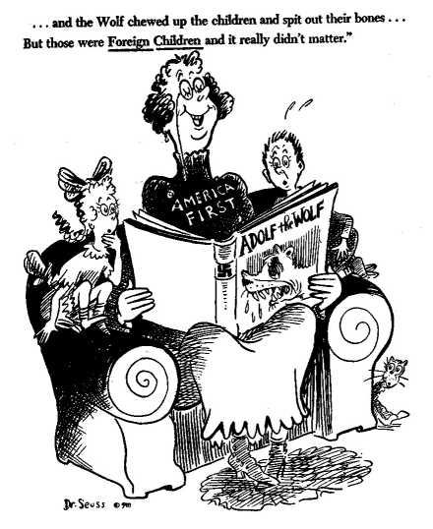

1. What do you think “America First” means? What group of people does it represent?
2. What is the book about?
3. What is the relationship of this cartoon to American Isolationism?
4. What message do you think this cartoon is trying to send?

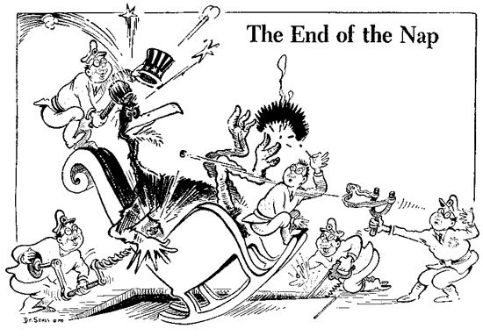

1. Who is the bird?
2. Who are the people attacking him?
3. What historical event does this cartoon represent?
4. Why do you think it is called “The End of the Nap”?