**WWII Maps**

**For both of these maps you will be labeling countries (which are numbered) and specific battles (which are listed with a letter). To label the battles, read the description and write the letter and name on the line.**

**Pacific Map**

Label countries 1-9:



Battles

* **This is the place where the first atomic bomb was released, killing 120,000 people.**

* **At these two battles, the US realizes how devastating a land invasion on Japan could be.**

* **This is a significant battle for two reasons, One is that General MacArthur is able to take back the Philippines. The second is that the Japanese begin using kamikazes.**

* **This is where the second atomic bomb is released; 74,000 people died and soon after Japan surrenders .**

**European Map**

Label countries 1-11



. Battles

* **This is also called Operation Torch. It is where the Allies attack Casablanca, Morocco, and Algeria trapping Rommel's troops. The Axis end up surrendering.**

* **This is where Germany's troops "freeze" because they are unprepared for winter. This battle is known as the turning point in the East.**

* **This is where Germans use the blitz to attack cities and military targets. Hitler ends up losing because Britain has radar which helps them fight off the air attacks.**

* **This was the last of Germany's counteroffensive. The Germans surprise the Americans, but in the end Germany is not able to recover and they lose the ability to fight. ,**

* **This was known as the Italian Campaign. This is the first city taken in the Campaign and Mussolini is killed.**

* **This took two years of planning to carry out and is known as the largest amphibious landing in history.**

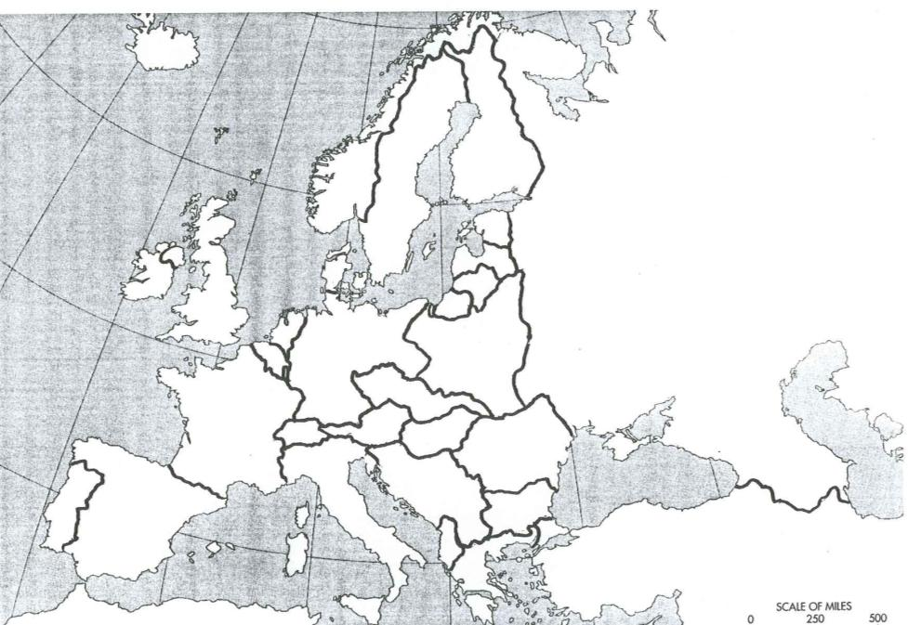

**A**

**B**

**E**

**5**

**9**

**8**

**7**

**10**

**6**

**4**

**3**

**C**

**2**

**D**

**F**

**1**

**11**

**3**

**F**

**4**

**2**

**8**

**7**

**6**

**5**

**3**

**1**

**D**

**C**

**B**

**A**