Germany

Key Dates in WWII Escalation by Country

*

*
*

*

*
*

*

*
*

*

*
*

*

*

*

*

*

1935
1936
1938
1939
1940
1933

Italy and Japan

Italy

*

*
All
Japan

Italy

*

*

Japan
Japan

Japan
Japan

1941
1940
1931

1932
1936
1937
1933
1935

Escalation Timeline Clues
Directions: Fit these clues on your Escalation Timeline BE SURE TO PAY CLOSE ATTENTION TO DATE AND COUNTRY!
- Germany battles Britain by air – Battle of Britain
- Nazi Party wins the majority in the Reichstag (Congress)
- Japan bombs the US at Pearl Harbor
- Italy assists dictator Franco in Spain
- Nuremberg Laws passed, stripping Jews of civil rights
- Germans and British sign Munich Pact giving Hitler part of Czechoslovakia
- Germany invades Poland
- Japan attacks China
- German military build up begins
- Germany signs a pact with Italy
- Krustallnact starts physical violence a/g Jews
- Germany march into Austria
- Czechoslovakia invaded by Germany
- Germany signs nonaggression pact with Russia
- Adolf Hitler b/c chancellor
- Japan, Italy and Germany form an alliance (Axis)
- Germany invades Belgium, Luxemburg, and the Netherlands
- Military leader Tojo take control of Japan’s government
- The League chooses to not defend Ethiopia
- Invasion of the Rhineland b/w Germany and France
- Italy signs a pact with Germany
- Germany takes over Paris
- Japan invades Manchuria
- Germany assists dictator Franco in Spain
- Italy invades Ethiopia
- Japan leaves League of Nations
- Germany leaves the League of Nations

America’s Neutrality Weakens

___________-FDR asks for $____ million for ____________

Publication of
_______________
_______________
_______________ Increases
_______________
feelings

Nye hearings conducted from ‘34 to ’36 to investigate

_____________
_____________
_____________ passed –can’t sell weapons to nations at war

_______: can’t loan $ to nations at war

______________
_______-US neutral in Spanish Civil War

___________- Recalls German Ambassador
Program to build ____________
______________________________

“____________
_____________
____________”: Countries must pay cash for weapons and transport themselves

1st Peacetime _________

“______________
_______________
__________”:
We __________ weapons in return for ability to ____________ naval bases.

__________: Cut off _______ with Japan

__________: Japanese Tojo sends _____________ envoy

__________:
_____________ Attack on
_____________
_____________

_____________:
_____________
_____________ signed w/ Churchill: US War _________

1934
1937
1936
1935
1938
1939
1940
1941

Pearl Harbor
Vocab:
Infamy—an event that people will remembered as wicked
Solicitation—upon the request of
Dastardly—underhanded, evil

Lead up to Pearl Harbor
- July 1941 – US with Japan (________________)
- Nov 1941 – Tojo sends envoy to US
- Dec 6, 1941 – all peace talks by Japan
- Dec 7, 1941 – on Pearl Harbor
Overview
- Pearl Harbor, on the Island of O'ahu, Hawaii was attacked by the Japanese Imperial Navy, at approximately , Sunday morning, .
- Surprise attack conceived by Admiral , including a striking force of Japanese aircraft
- Approximately US Naval ships were present that morning, including battleships, destroyers, cruisers and various support ships.
- Over the U.S. Pacific fleet was out to , including the .
- Simultaneously, was also the victim of the surprise attack
  - 18 aircraft including bombers, fighters, and attack bombers were destroyed or damaged on ground.
  - A few U.S. fighters struggled into the air against the invaders and gave a good account of themselves.
- A total of Japanese aircraft were shot down by ground fire and U.S pilots from various military installations on O'ahu.
- .
FDR’s Declaration of War speech: Answer these questions as you listen to the speech
- What does FDR call Dec 7, 1941?

- What made it obvious that this was a planned attack?

- Name 3 other places Japan attacked.

- What does FDR predict will be the outcome of the war?

- When does FDR state that a state of war existed between the US and Japan?

Mobilization Needs & Solutions
Expansion of the military
War material production &reliable workforce
Raise money & balance the economy
National security | 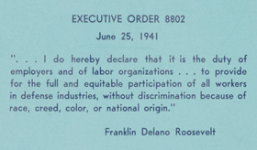
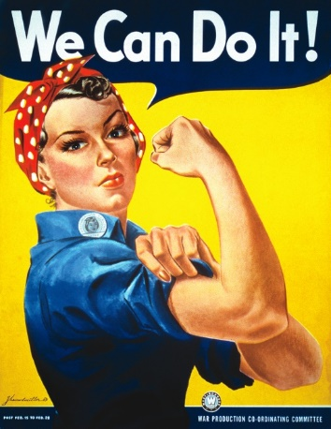

War Theaters Chart
Theater | Goal | Major Battles/ Strategies | Key People | Year | Outcome
Atlantic
North Africa
Europe
Soviet Union
Pacific

End of WWII Key People & Conferences

 | 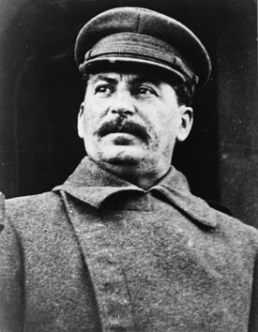 | 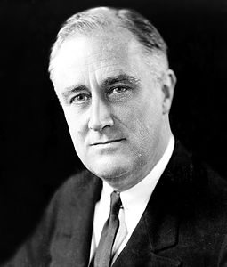 | 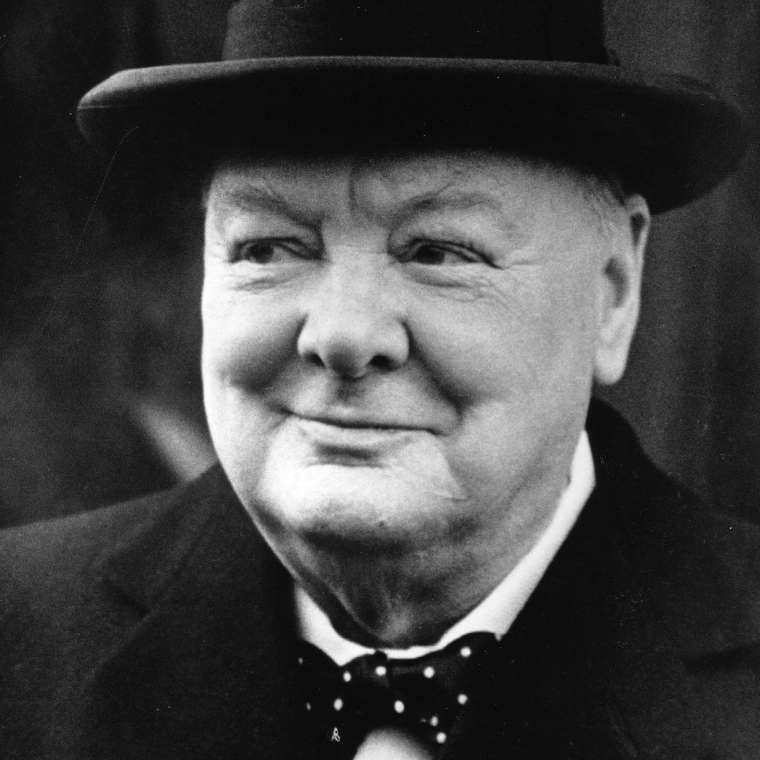 | 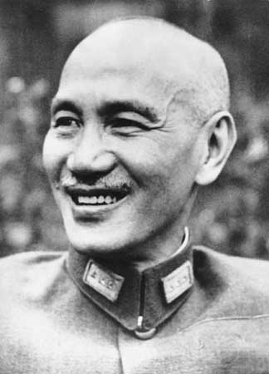 | 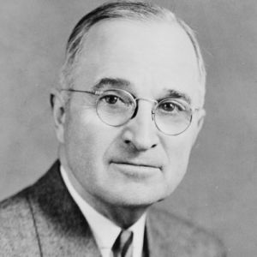
Name
Country
Personality

War Conferences During World War II
Conference / Date | Who attended | Major Decisions
Cairo, Egypt  Nov. 1943 | FDR, Churchill, Chiang Kai-Shek | - _________ to be independent  - ________ returned from Japan to _________
Teheran, Iran  Nov. 1943 | FDR, Churchill, Stalin | - The US and Britain will open a “second front” in ________ to take German pressure off the _________.  - ___________ will come help the US beat ________ after Hitler is defeated.
Yalta, USSR  Feb. 1945 | FDR, Churchill, Stalin | - ________________ trials will be held  - The _______________will replace the League of Nations  - Germany will be divided into _______ zones, as will the capital ________, and rebuilt by ________.  - The US will give the USSR islands in the Pacific to entice them to come help us defeat _________.
Potsdam, Germany  July 1945 | ____________, Churchill, Stalin | - 6.5 million Germans will be relocated back to Germany from _________________ Europe
San Francisco, USA  April, 1945 | Representatives of 50 nations | - They set up a new world organization called the _________________________  - All nations could have a seat in the _________________.  - The Allied powers of WWII (___________________________) will have permanent seats on the ______________________.  - The Security Council can ______ any decisions made in the ____________________.  - All other nations will share _____ rotating seats on the Security Council.
Washington, D.C.  1945 | Eleven Nations of the Far East Commission | - _____________________ will lead the US occupation of Japan until______.  - Freedom of the press, women’s rights, and labor unions will be protected  - Large businesses were broken up.

